**CHILTERN FLY TYING & FLY FISHING**

**BLACK CRUNCHER**

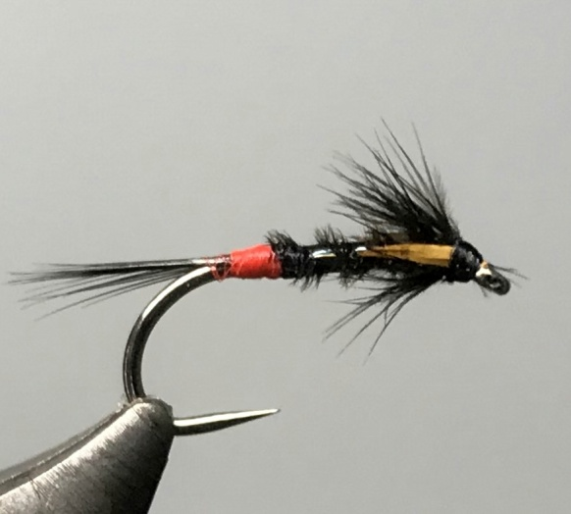

Materials:

Black nickel hook size 10-12; Black thread; red floss glo-brite no4; natural black cock pheasant tail (melanistic); black holographic medium tinsel; natural black cock and hen hackles; jungle cock cape feathers or sunburst goose biots.

Tying Instructions

1. Place the hook in the vice and run the thread down to a position opposite the hook point and select a bunch of cock hackle fibres for the tail and tie the fibres in about ¾ the shank length.
2. Bind the waste fibres down by winding the thread up the shank trimming any that are too long, and then return the thread to where the tail fibres were tied in.
3. Tie in a suitable length of black holographic tinsel
4. Take a length of red floss and double it and tie this in by the loop end at the tail position then wind the thread up the shank.
5. Wind a red tag up the shank approximately 2-3 mm long then tie off and trim.
6. Select 3 or 4 pheasant tail fibres and tie in by the tips then return the thread up the shank to 2mm behind the eye.
7. Twist the pheasant tail fibres into a loose rope and wind a body up the shank to the thread position, tie off and trim the waste.
8. Wind the holographic tinsel up the shank in opposite open turns (4 turns on a size 12) tie off and trim the waste.
9. Select a short black hen hackle and prepare the tip to tie in 2mm back from the eye.
10. Wind the hackle forward 3-4 turns, then tie off and trim the waste using a scalpel or the crook of the scissors.
11. Stroke the hackle fibres back and secure with 2 turns of thread.
12. Prepare the goose biots or jungle cock feathers and tie in either side of the hackle along the shank to form wing buds.
13. Trim the waste ends of the wing buds and finally whip finish and varnish.