**CHILTERN FLY TYING & FLY FISHING**

**MUSKINS FLY**

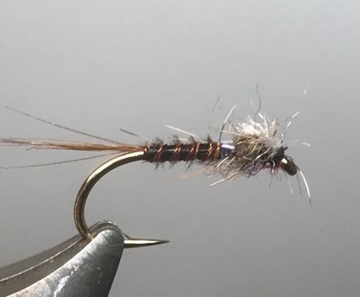

Materials:

Kamasan B175 10/12; black thread; red wire ribbing; game cosk hackle; dyed black cock pheasant tail; medium ice blue pearl mylar; fox squirrel or similar spiky dubbing; white Anton or similar breather material.

Tying Instructions:

1. Place the hook in the vice and run the thread down to the start of the bend.
2. Tie in some game cock hackle fibres for the tail (alternatively use coq de leon), trim and bind down the waste winding the thread up the body, keeping a slim profile.
3. Tie in the wire at this point and wind the thread back to the bend binding in the ribbing as you go.
4. Take 2 black cock pheasant tail fibres and tie in by the tips and bind down, then wind the thread back approx. 2/3 of the shank binding down the waste as you go.
5. Twist the pheasant tail fibres into a rope using some hackle pliers and wind the body in touching turns up to the thread position, then tie off and trim.
6. Wind the ribbing in the opposite direction to the body material using 4 evenly spaced turns. Tie off and remove the waste wire by wiggling the wire to break rather than cutting.
7. Tie in the mylar and make 3 or 4 turns one over the other to create a solid colour band no more than 1.5mm wide. Trim the waste.
8. Tie in 2 cock pheasant tail fibres for a thorax cover and bind down and remove the waste.
9. Dub on the fox squirrel dubbing and wind a sparse thorax.
10. Pull over the pheasant tail for a thorax cover then trim the waste.
11. Tie in the breather material at right angles to shank and secure with a figure of 8 binding.
12. Tie a neat head, whip finish and trim the thread and trim the breathers short no more than 2mm either side,
13. Varnish the head.