**CHILTERN FLY TYING & FLY FISHING**

**MUDDLER MINNOW**

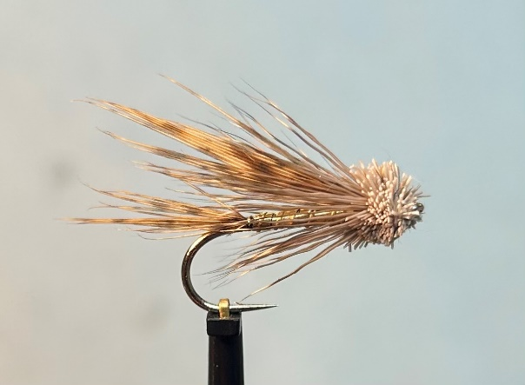

Materials:

Long shank hook 6-10; strong fine thread (tan or white); Hen Pheasant primary feathers (matching pair) or centre tail wing and tail; oval gold tinsel or wire (size to suit) rib; flat gold tinsel body; Deer hair ruff and head.

Tying Instructions:

1. Place the hook in the vice, tie in the thread at the eye then wind a foundation to the start of the bend.
2. Select a slip of feather approx. 4mm wide from each side of the Hen Pheasant feather and place together good side to good side.
3. Offer up to the shank approximately 2/3rds the length of the body and tie in on top of the shank with a pinch and loop so that the wing slips sit directly on top of the shank (not around the hook shank!). Bind down the waste ends towards the eye to form a slim body.
4. Tie in the oval tinsel then the flat gold and bind down the waste ends towards the eye (trimming if necessary) and end up with the thread ¾ down the shank (from the bend).
5. Apply a thin smear of varnish/super glue on the body and wind the flat tinsel up the body in overlapping turns and tie off at the thread position. Trim the waste.
6. Rib the gold body with the oval tinsel and tie off. Trim the waste.
7. Make sure the remaining shank is flat and free of any waste. Bind down with the thread leaving it at the end of the gold body.
8. Take similar slips of the wing feather used for the tail this time approximately 6mm wide and tie in using the pinch and loop. When you are satisfied with the wing continue binding the thread down to secure the wing. Trim any waste then wind a flat or slightly tapered tidy foundation leaving the thread in front of the wing.
9. Take a large pinch of the deer hair (approximately the diameter of a pencil) and cut off the deer skin.
10. Whilst firmly gripping the tips of the deer hair brush out thoroughly any underfur or loose hairs. Place into a hair stacker, tips first then tap the stacker to align the tips.
11. Carefully remove the bunch of hair and offer up to the hook with the tips approximately half way up the wing.
12. Take 2 loose turns of the thread around the hook and deer hair whilst still holding onto the bunch of deer hair. Take 1 further turn of thread pulling tightly whilst letting go of the deer hair so that it flairs and rotates around the hook.
13. Make 2 or 3 further tight turns through the flared deer hair, then pull back the deer hair and make locking turns in front. The deer hair can be compacted with the use of the hollow end of a dubbing needle or empty Biro pen.
14. Depending on the amount of shank left select another bunch of deer hair and remove the underfur. This can be offered up to the shank and tied in exactly the same as the first.
15. After securing the deer hair encourage all of the fibres back so that a small head can be formed with the tying thread.
16. Apply some varnish to the thread then whip finish the fly.
17. Trim the deer hair to shape avoiding the tips that were tied in first.