PHEASANT TAIL NYMPH

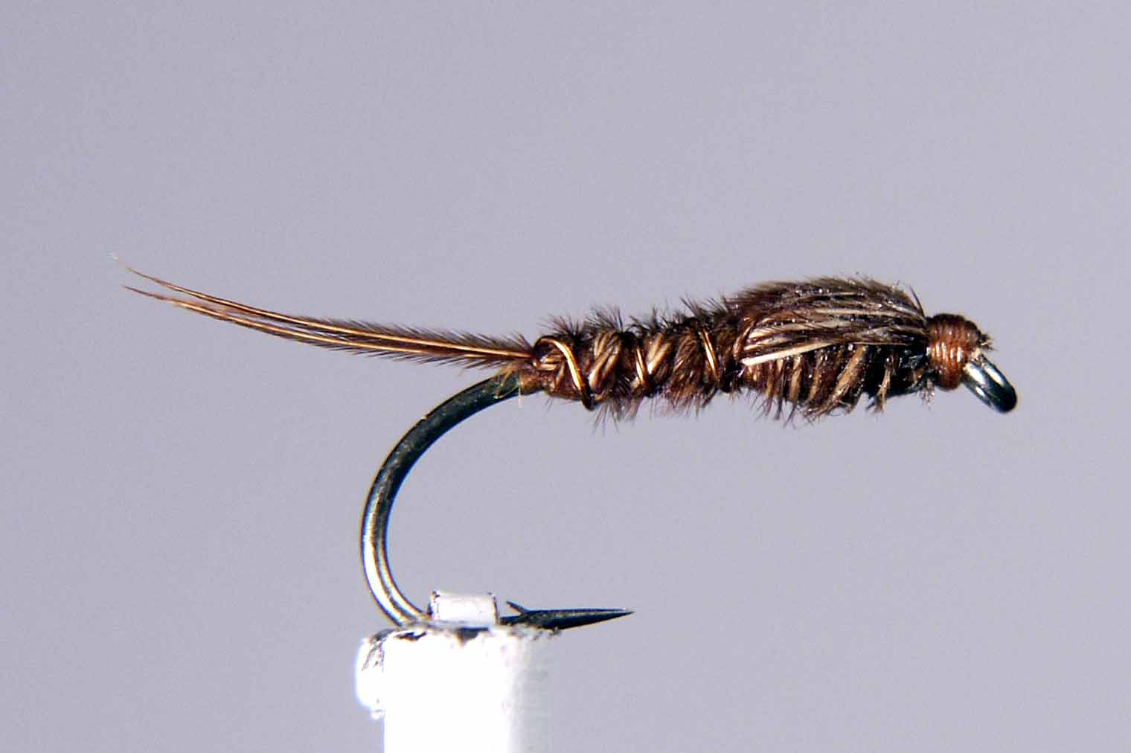

Materials

Size 10-16 Medium/Heavy Std shank hook, tan/brown thread, thin copper wire, cock Pheasant Centre tail.

Tying Sequence

- Attach thread to shank 2mm behind the hook eye then wind in close touching turns down the shank to a position just in front of the bend.
- Select a small bunch of Pheasant tail fibres, align the tips and tie these in to form the tail approx. 2/3 length of the shank.
- Tie in a suitable length of copper wire and bind this and the tail fibres down in open turns to approx 2/3 length of the shank. Remove the surplus pheasant tail fibres and return the thread back to the bend.
- Tie in another bunch of P.T. fibres this time by the trimmed tips and wind the thread back towards the eye and stop approx 2/3rds along the shank.
- Wind the P.T. fibres down to the thorax position in close touching turns and tie off on top of the shank. If the P.T. fibres are long enough bind these down so that they face back towards the tail.
- If the fibres are not long enough, tie in another bunch of fibres so that ends are facing towards the bend of the hook.
- Wind the ribbing material in opposite, open turns to the thorax position making sure you don’t trap the thorax cover fibres .
- A weighted thorax can be added with the copper wire at this stage
- A thorax of a variety of materials can be added now but care must be taken not to crowd the eye.
- With the remaining P.T.fibres, pull over the thorax of your choice to form the wing case and bind the fibres down to secure before trimming.
- Form a neat head, whip finish and varnish.

