**CHILTERN FLY TYING & FLY FISHING**

**LEE’S SCRUFFY BUZZER**

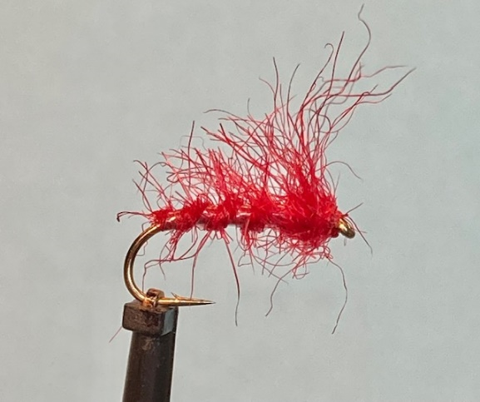

Materials:

Light wire Dry Fly hook size 12 (Kamasan B170 or similar); Well mixed seal’s fur, colour to suit; clear mylar 1/32-inch UNI-Mylar #14 (alternatively: clear Antistatic packaging Material); thread colour to match dubbing. (UTC 70 den). A preferred liquid flotant. (Dry Fly Silicon Mucilin)

Tying Instructions:

1. Place the hook in the vice and wind the thread onto the shank for approximately 3mm.
2. Catch in a length of the clear mylar on the far side of the hook shank then continue the thread down to the start of the bend.
3. If the ribbing is too wide for the hook size a gentle stretch will reduce the width.
4. Take a small pinch of the seal’s fur and tease out the fibres and fold back in the same plain to try and align the fibres. Do this several times and then cut the bunch of seals fur in half so that you shorten the seal’s fur fibres.
5. Moisten your index finger and thumb then offer this bunch of dubbing up to the thread.
6. Gripping the dubbing and thread very tightly grind the dubbing around the thread in one direction only.
7. Once a small section of the dubbing is tightly wrapped around the thread slide this up to the hook and take 1 or 2 turns to secure and lock in the seal’s fur fibres to form the anchor point
8. Continue to moisten (**not wet**) the fingers and ‘grind ‘the fibres around the thread to create a dubbing rope and wind this around the shank up towards the eye position.
9. The density of the dubbed body needs to be slightly higher than the hare’s ear pattern previously tied as this is going to be brushed out with a Velcro brush so as to absorb as much flotant as possible.
10. Once you reach just short of the eye position slide any surplus dubbing down the thread to use later, Tie in any loose fibres.
11. Wind the ribbing in the same direction as the dubbing up the shank in open even wraps. (**Not too tightly**).
12. Tie off just behind the head and trim the waste.
13. Slide any remaining dubbing back up the thread (or add fresh seal’s fur) and wind a chunky thorax. (This will be brushed out at the next stage) and finish the thread behind the eye.
14. Remove any surplus dubbing from the thread and bind down any stray fibres. (With minimal wraps of thread)
15. Apply a thin smear of varnish onto the thread and whip finish the thread to secure bur do not form a head.
16. When the varnish is dry brush out the seals fur as per the above sample. You can trim any loose fibres from the body area if you wish but leave the thorax as straggly as possible.
17. A good suggestion is at this stage to soak the fly in a suitable flotant so that it can fully dry before putting it into a fly box