**CHILTERN FLY TYING & FLY FISHING**

**MICRO BUG**

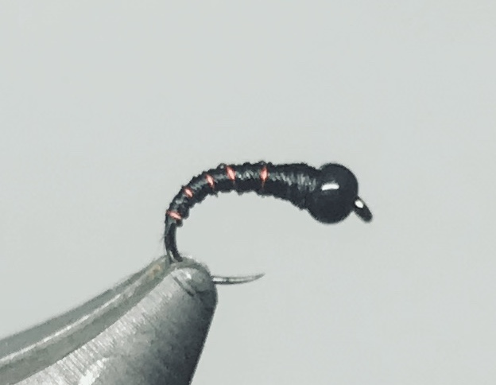

Materials:

Small grub hook size 20; 1.5-2.0mm black tungsten bead; fine black thread (Veevus 16/0) or any thread that can be wound flat; ultra fine red or silver wire

Tying Instructions:

1. Place the bead on the hook and put it in the vice ( place the hook in the vice gripping the shank vertically with the hook point upwards, pick up the bead with the point of a small dubbing needle and place it over the hook point).
2. Wind the thread onto the shank at the eye and wind the thread down around the bend and catch in the ribbing wire.
3. Flatten the thread by spinning the bobbin holder then wind a slim tapered body up and down the shank continuing to flatten the thread so as not to create too much bulk, finish the body behind the bead.
4. Rib the body in 5 open even turns and tie off behind the bead.’ Worry’ the wire waste off.
5. Finally whip finish behind the bead and varnish.