**CHILTERN FLY TYING & FLY FISHING**

**HOTSPOT NYMPH 2**

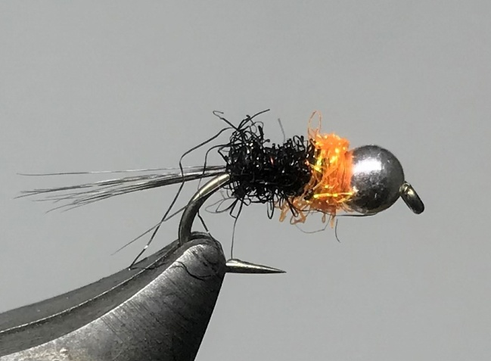

Materials:

Jig or heavy wire hook size 14-16 slotted or countersunk tungsten beads in silver; coq-de-leon feather; small red wire; orange thread; Hends Spectra #45 black peacock; Hends Spectra #294 Hot Fluo orange

Tying Instructions

1. Put the bead on the hook either with the slotted bead on the jig hook or the countersunk bead **facing** **the eye**, place the hook in the vice.
2. Wind the thread down to the start of the bend and catch in 5/6 coq de leon fibres to form a tail just short of the length of the shank.
3. Tie in the red wire for the rib and return the thread to the back of the bead tying down the tail fibres and wire. Trim any waste.
4. Return the thread to the tail position and dub on the black peacock dubbing.
5. Dub a neat body up the shank leaving enough space behind the bead for a small thorax, remove any excess body dubbing
6. Rib the body with open even turns of wire in the opposite direction to the body material, (4-6 turns depending on hook size), secure with the thread and ‘worry’ the wire off.
7. Dub on a small amount of the orange material and wind a thorax finishing tight up against the bead.
8. Varnish the thread and whip finish behind the bead.