PETER ROSS

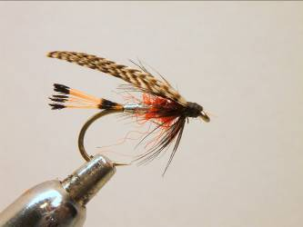

Materials
Standard wet fly hook 8-14, black thread, silver mylar, oval silver tinsel, red seals fur, black hen hackle, golden pheasant tippet, teal barred flank feather.

Tying Sequence
- Tie on the thread and wind a foundation to the bend where we will tie in the golden pheasant tippet. Make sure the length of the tail including both black bars is the same as the length of the shank.
- Catch in a suitable length of oval silver tinsel under the shank and bind it down as you return the thread to the mid point position where you will tie in a length of flat silver mylar.
- Wind the silver mylar down to the tail position and back and tie of and trim the waste.
- Dub on the seals fur and wind the front section of the fly to a position 3mm behind the eye.
- Wind the oval silver tinsel as a ribbing down the body in open even spirals and tie off 3mm behind the eye.
- Select a suitable sized black hen hackle and pre pare it to be tied in by the tip.
- Wind no more than 2 turns of the hackle and tie of and trim the waste.
- Sweep the hackle fibres back and under the shank to form a beard hackle and bind down with turns of thread making sure that a good foundation is formed for the wing.
- To prepare the wing you will need to stroke the fibres of the teal feather to a right angle from the stalk so that the fibres marry back to each other and the tips are roughly in line.
- We will need a slip of feather approx. 3 times the width of the final wing which can then be cut from the feather.
- To form the wing we need to divide the feather ino 3rds. With the good side facing down fold the top third over, then fold the bottom 3rd upwards over the first fold, this will now form the wing which is tied on top of the shank just above the beard hackle.
- Bind down the wing firmly before trimming then form a neat head.
- Whip finish and varnish the head.

