**CHILTERN FLY TYING & FLY FISHING**

**GINGER TOM**

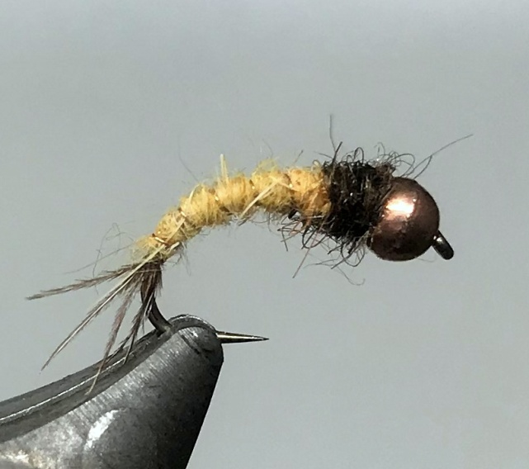

Materials:

Grub or jig hook sizes 14-18; brown or tan thread; copper coloured bead head 2.8mm- 2.0mm depending on hook size on either tungsten or brass depending on depth required; cock pheasant centre tail fibres; pale copper wire; ‘light ginger’ dubbing, e.g. : Wapsi rabbit, Life Cycle Nymph Ginger, Fly- Rite #36 ginger cream, SLF #40, Nature Spirit Tannish Yellow; dark brown dubbing, e.g, Life Cycle Nymph dark brown or Fly-Rite#6.

Tying Instructions:

1. Place the bead on the hook either slotted bead on the jig hook or countersink on grub hook and place in the vice.
2. Tie on the thread at the eye and wind the thread down the shank and half way round the bend.
3. Tie in 4 pheasant tail fibres to form a short tail and catch in the copper rib.
4. Wind the thread back to the bead position trapping in the tail fibres and ribbing, then trim any waste.
5. Return the thread to the tail position and then dub on the ginger dubbing.
6. Wind the dubbing rope up the shank to form a slim, slightly tapered body leaving space behind the bead for a thorax.
7. Wind the rib in open even turns (4-6 depending on hook size), up the shank in the opposite direction to the dubbing and then tie off and break off the waste by ‘worrying’ the wire.
8. Dub on a short thorax and whip finish behind the bead, varnishing the thread before you do so.
9. Pick out some of the thorax fibres