**CHILTERN FLY TYING & FLY FISHING**

**CLARET HOTHEAD DIAWL BACH**

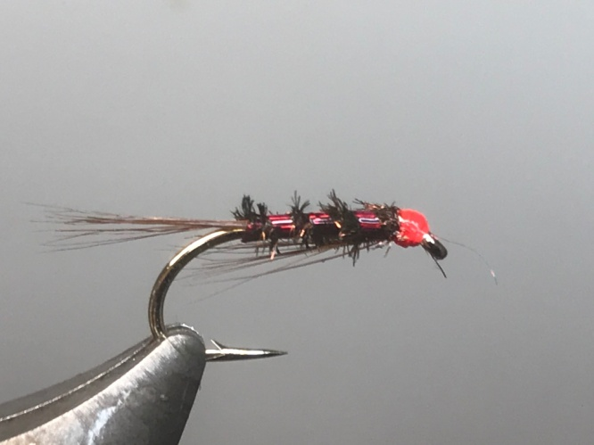

Materials:

Kamasn B175 size 12 or similar; wine thread; cranberry holographic mylar; claret cock hackles; natural peacock herl ; glo-brite No4 floss (optional)

Tying Instructions:

1. Place the hook in the vice and run the thread down to the start of the bend.
2. Tie in some hackle fibres for the tail (alternatively use coq de leon), trim and bind down the waste winding the thread back up the body, keeping a slim profile.
3. Tie in the mylar at this point and wind the thread back to the bend binding in the ribbing as you go.
4. Take 1 peacock herl and tie in by the tip and bind down, then wind the thread back in touching turns to approx. 3mm from the eye.
5. Wind the peacock herl up the body in slightly open, **opposite** turns to the thread position and tie off and trim.
6. Wind the mylar rib up the body material using 3 evenly spaced turns. Tie off and remove the waste.
7. Turn the hook over in the vice or rotate to enable tying in the throat hackle.
8. Select a few strands of the cock hackle and offer up to the fly so that the fibres measure no longer than the body, trim to length, then tie in to run down the body.
9. At this stage you can whip finish and varnish. Alternatively you can tie in a length of hot-head floss.
10. Whip finish with the tying thread and trim, then wind a neat head with the floss before finally whip finishing with the floss.
11. Trim the floss and apply a varnish, preferably one that does not discolour the floss.