**CHILTERN FLY TYING & FLY FISHING**

**EMERGING DEER HAIR SEDGE**

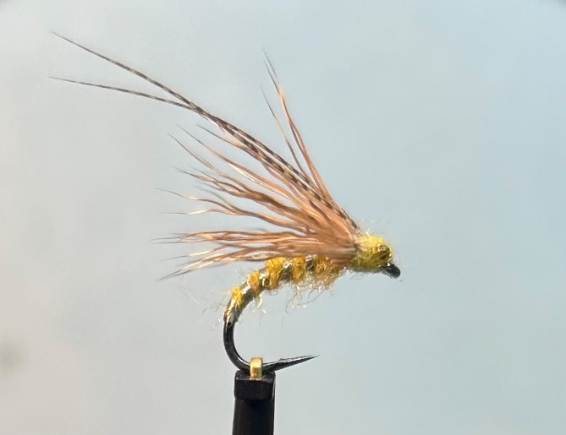

Materials:

Medium wire buzzer/emerger hook 12-16; strong thin white or yellow thread; Clear tinsel rib; Pale yellow/light olive fine dubbing; Wide opal tinsel thorax cover; Bronze Mallard feather fibre ‘horns’; Deer hair wing yellow mono dumbbell eyes.

Tying Instructions:

1. Place the hook in the vice, tie in the thread at the eye then wind a foundation ½ way around the bend.
2. Catch in the clear tinsel rib then bind the waste up the shank. Return the thread around the bend
3. Dub on the body dubbing material and form a fairly tight rope and wind a slim slightly tapered body approximately ¾ up the body. Remove any surplus dubbing and tie off,
4. Take the clear tinsel and wind up the body in open even spirals and tie off at the end of the dubbed body. Remove the waste and tie off.
5. Tie in a short length of the opal tinsel so that it extends back over the body. Bind down the waste and trim’
6. Wind a flat foundation of thread for the wing and leave the thread at the point where the opal tinsel was tied in.
7. Select a small bunch of deer hair and cut off the skin, remove all the underfur and loose fibres and place into the hair stacker tips first. Tap the base of the stacker on a hard surface to align the tips.
8. Remove the stacked hair and hold by the butts of hair and offer up the tips to the fly so that the tips extend approximately the length of the shank (but not any longer). Note how much material needs to be cut off.
9. Swap the hold of the wing to the other hand and trim the butts to length
10. Offer the wing bunch up to the shank and tie in the trimmed ends so that no fibres extend any more than 1.5mm behind the eye. Keep hold of the wing material until it is firmly in place.
11. Take firm thread wraps over the cut ends to bind down. A small dab of glue will help to keep the fibres locked in.
12. Split the wing fibres in half and pull over the thorax cover over the base of the wing to splay it. Bind down the waste and trim.
13. Select 2 bronze mallard fibres and tie in over the wing and slightly splay each side. Bind down the waste and trim.
14. Take a 10mm length of the yellow mono and place midway in a pair of tapered tweezers. Singe both ends of the mono with a flame to create a dumbbell. The gap between the ‘eyes’ should be a bout 3mm.
15. Using the tips of the tweezers offer up to the head of the fly. Tie in and use a figure of eight to position and secure.
16. Dub a small amount of the body dubbing onto the thread and wind over thread wraps behind the eye.
17. Finally whip finish and varnish the head.