BLOODWORM (WOBBLEWORM)

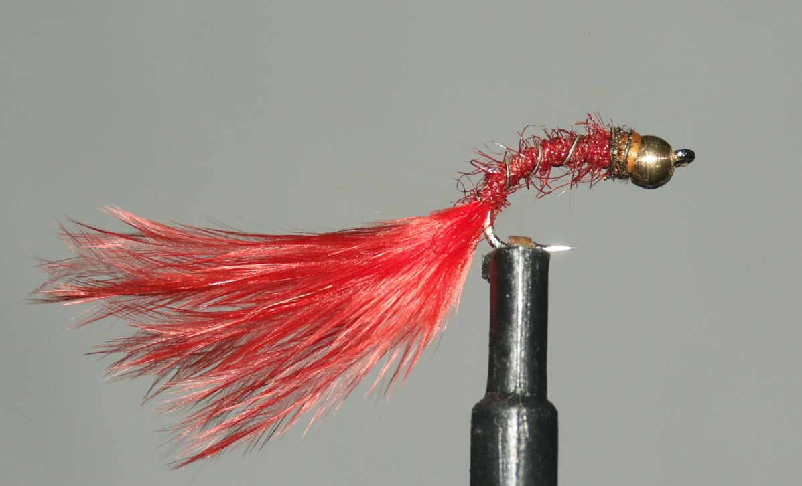

Materials

10-14 wide gape heavyweight grub/sedge hook, red/black thread, gold/tungsten bead, peacock herl, oval gold rib, red seals fur or similar, red marabou.

Tying Sequence
- Place the bead onto the hook making sure the countersink side is towards the bend.
- Tie on the thread and wind it down the shank and round the bend and tie in a prepared bunch of marabou. Bind the butt ends down to form a neat body and return the thread around the bend.
- Tie in the ribbing material and dub on the seal’s fur.
- Wind a slim body up to within 2mm of the bead and remove any excess dubbing.
- Wind the rib up the body in open even spirals and tie off.
- Tie in a single strand of peacock herl and wind this up to the bead and tie off and trim the waste.
- Finally whip finish behind the bead taking care not to bury the peacock herl. It is not possible to varnish the whipping so an addition whip might be advisable.

