**CHILTERN FLY TYING & FLY FISHING**

**LEE’S KILLER BUG**

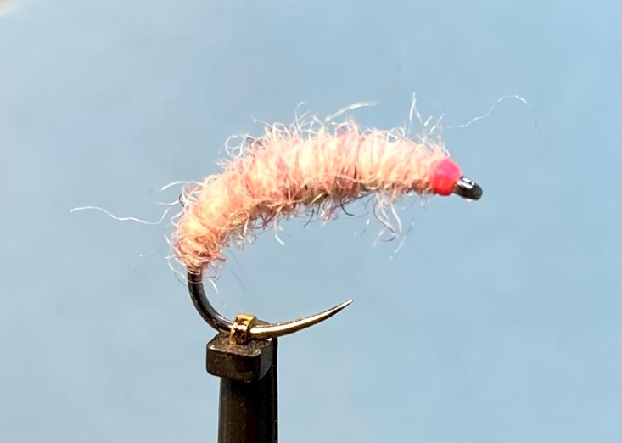

Materials:

Grub hook size 12 ( Dohiku 644); flat or flattened lead; fluorescent pink thread (UTC 70 denier)

Jamiesons Spin Drift Shetland wool – Wild Velvet

Tying Instructions:

1. Place the hook in the vice, tie on the thread at the eye, then wind a thread foundation in touching turns to half way round the bend. Apply a thin coat of varnish or superglue to stabilize the thread.
2. Either flatten the lead wire or use flat lead strip. In touching turns starting 1 mm back from the eye, wind the lead and finish just around the bend. Pull off the remainder and attach the lead back at eye position short of where the first layer started and wind a second layer finishing shorter than the first layer. If a third layer is required then follow the previous steps.
3. Flatten any unevenness in the lead underbody then wind the pink thread up and down the shank to obtain an even colour and a taper at the eye and the bend. Finish the underbody at the back of the hook. (If you do not have pink thread then tie in a length of globrite no.2 and wind this instead)
4. Tie in a length of wool at the back and take the thread back to the eye.
5. Wind the wool up the body in close tight turns and tie off at the head. Trim the waste.
6. Form a neat pink head then whip finish and varnish.