**CHILTERN FLY TYING & FLY FISHING**

**BLACK FLEXI FLOSS BUZZER**

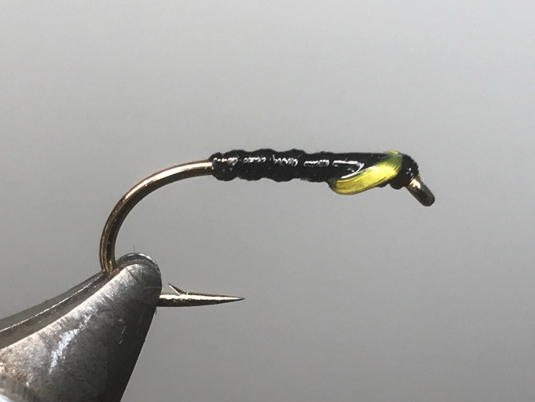

Materials:

Kamasan B175 size 10/12; black thread; black flexi floss; sunburst yellow flexi floss.

Tying Instructions:

1. Place the hook in the vice and run the thread down to a position just short of the bend of the hook and return the thread to the eye.
2. Tie in a length of black flexi floss securely and pull the floss tight to reduce the thickness and bind down with the thread to the position of the end of the foundation thread, return the thread to approx. 2mm back from the eye.
3. Pull the flexi floss tight and wind in close even turns towards the thread reducing the tension on the floss with each turn so as to increase the thickness of each turn of rib. Aim to get 5 turns on a size 10.
4. Tie off the floss securely and either whip finish or half hitch the thread to prevent the floss from unravelling. Trim the waste.
5. Using the tying thread wind a thorax and position the thread approx.3-4mm back from the eye.
6. Take a small length of the sunburst flexi floss and tie in beneath the hook by looping the floss around the thread and pulling the loop into position following this with a few turns of thread in front
7. Reposition the hook angle so that the thread doesn’t slip off when tying off the flexi floss cheeks.
8. Pull the 2 strands of flexi-floss at a 45 degree angle around each side of the thorax under a small amount of tension and bind down on top of the shank just back from the eye, secure with a half hitch or whip finish.
9. Trim the flexi floss by pulling tightly and cutting closely to the thread.
10. Finally whip finish and fully varnish the fly trying to keep the profile of the flexi floss.