**CHILTERN FLY TYING & FLY FISHING**

**UV CRUNCHER**

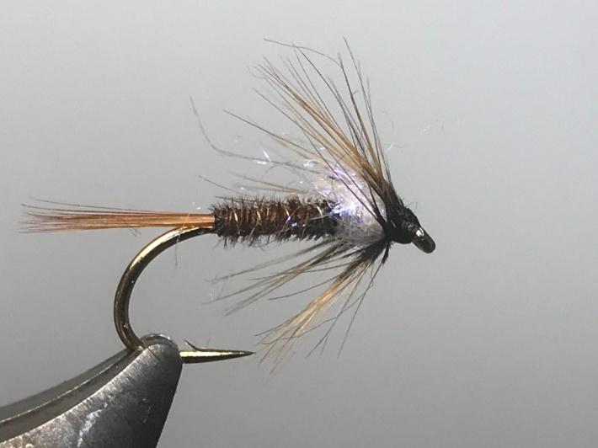

Materials:

Kamasan B175 10/12 or similar; black thread; gold/silver wire; red game cock hackles; cock pheasant tails; UV lite bright dubbing or similar, greenwells hen hackles.

Tying Instructions:

1. Place the hook in the vice and run the thread down to the start of the bend.
2. Tie in some hackle fibres for the tail (alternatively use coq de leon), trim and bind down the waste winding the thread up the body, keeping a slim profile.
3. Tie in the wire at this point and wind the thread back to the bend binding in the ribbing as you go.
4. Take 3 cock hackle pheasant tail fibres and tie in by the tips and bind down, then wind the thread back approx. 2/3 of the shank binding down the waste as you go.
5. Twist the pheasant tail fibres into a rope using some hackle pliers and wind the body in touching turns up to the thread position, then tie off and trim.
6. Wind the ribbing in the opposite direction to the body material using 4 evenly spaced turns. Tie off and remove the waste wire by wiggling the wire to break rather than cutting.
7. Dub onto the thread some UV body material and wind a bulky under thorax up to approx 2mm from the eye. Clean any remaining dubbing from the thread and prepare a base for the collar hackle.
8. Select a greenwells hen hackle that is just short of the length of the body and prepare to tie it in by the tip.
9. Tie in and secure the tip of the hackle concave side down then trim the waste Wind the thread forward. Double the hackle fibres either side of the stem with damp fingers then wind the hackle using no more than 3 turns (less on the smaller fly), then tie off. Sweep the hackle back and bind down any stay fibres trying to avoid flattening the hackle.
10. Finally whip finish, tie off, trim and varnish the thread.