**CHILTERN FLY TYING & FLY FISHIG**

**QUILL BODIED PARACHUTE FLY**

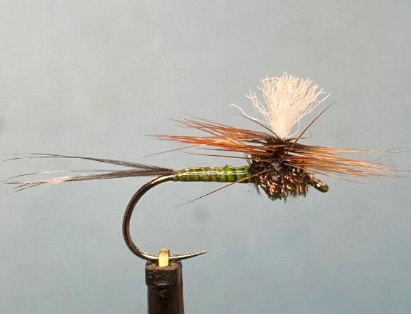

Materials:

Light wire dry fly hook to suit (Hanak 130BL Dry Fly size 10); white GSP thread (Veevus G02 GSP 30 denier); white floating yarn post (Fish On Ultra-dry-Yarn white); parachute hackle colour to suit; coq de leon tail; stripped peacock quill colour to suit; peacock herl thorax; Permanent marker pen to suit body colour.

Tying Instructions

1. Apply a thin smear of super glue to the shank then attach the thread and tie a foundation to the glued area and return the thread to 2-3mm back from the eye.
2. Select a suitable thickness of the post material and tie onto the top of the shank extending approximately 30-40mm over the eye.
3. Trim the waste material that’s over the body at an angle and wrap the thread over the waste ends winding towards the tail. Return the thread back to the wing post.
4. Apply a little wax to the thread then lift the post to the vertical and wrap several turns of thread in front of the post to secure it in the vertical position.
5. Add a bit more wax if needed and wind around the post starting at the base. You will need to keep the post vertical with one hand whilst wrapping the thread with the other. Aim for approximately 3mm of wraps then return the thread to a position behind the wing.
6. Select a suitable hackle whose fibres are just short of the body length. Remove the base fibres then hold the hackle concave side up and stroke the fibres back so that the fibres stand at right angles. Still with the hackle concave side up and tip pointing away from you remove the fibres from right hand side of the hackle.
7. Cut the stalk about 4mm from the fibres on the other side and offer this up to the post vertically so that the cut end extends just below the shank against the wing post. The hackle fibres should be on the right of the wing.
8. Wind the thread around the base and stalk to secure, then wind the thread up the post and hackle stalk and back down again. Continue winding the thread to the tail position. A thin smear of super glue around the base of the wing will help to stabilise it.
9. Using a coloured pen to match the body, colour the thread wraps and a length of the thread.
10. Take about 6 coq de leon feather fibres align the tips and pull off the stalk and tie in at the tail position with the tips extending approximately the length of the hook shank. Secure the tail, trim the waste and bind down any stray fibres. Take a couple of thread wraps under the tail fibres to splay the tail.
11. Select a stripped peacock quill and tie in by the tip then return the thread to the eye.
12. Attach the hackle pliers to the butt of the quill and wind up the shank in touching turns to the post and tie off.
13. Apply some uv resin or varnish to the quill to protect it
14. Catch in a single peacock quill at the head then return the thread to behind the post. Apply some super glue and carefully wind the herl to the post and figure of eight wrap around the base and tie off leaving the thread at the back of the post.
15. Holding the tip of the hackle start to wind it around the wing post keeping tension on the post with the other hand and wind down in close touching turns to the peacock thorax. Keeping tension on the hackle take a couple of securing wraps vertically around the hackle. Once it is is secure you can let go of the hackle and take a couple more vertical turns through the wing.
16. Carefully whip finish the thread through the hackle before removing the waste stalk and thread. Applying a small of varnish to the thread before whip finishing might be easier than trying to varnish it once the thread is removed
17. Finally trim the length of the wing post to suit.