**CHILTERN FLY TYING & FLY FISHING**

**CHARLES JARDINE’S DUCK’S DUN**

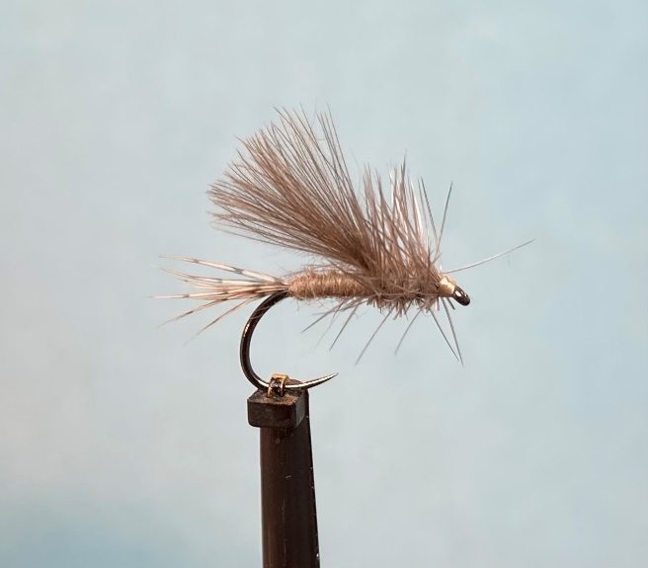

Materials:

Dry fly hook size 14 (Fulling Mill 5050); white thread; soft fibre tail (partridge hackle fibres); mink under fur body; natural cdc feathers; dun coloured cock hackle; muskrat thorax.

Tying Instructions:

1. Place the hook in the vice and run the thread down the shank to the bend.
2. Select a soft hackled feather (partridge) and pull out the fibres to align the tips then pull off the stalk.
3. Judge the length of the fibres to equal the body length of the fly and tie in on top of the shank at the start of the bend.
4. Continue to wind the thread down to trap in the waste and then trim at an angle. Bind over the waste ends and return the thread to the tail position.
5. Dub on the mink under fur sparingly and trap the the start of the dubbing in with a couple of turns of the thread. Spin the dubbing on the thread and wind a slim tapered body up to the thorax position. Remove any surplus material.
6. Select 2 cdc feathers and place them back-to-back with the tips aligned to form the wing. Offer the wing up to the hook to gauge the wing length making it equal to the shank length.
7. Tie this wing in at the back of the thorax on top of the shank with a pinch and loop so that the wing sits directly on top of the shank. When you are happy with the position bind down the waste and trim at an angle and bind down and return the thread to the wing.
8. Select a dun-coloured hackle to suit the hook size and prepare it by stripping away the base fluff and any unwanted fibres.
9. Tie this hackle in at the side of the shank just under the wing base and wind the thread forward tying in the hackle stalk then trim any waste.
10. Dub on a mixture of muskrat and the mink underfur and form a thorax and finish at the eye.
11. Take the hackle stalk and wind 1 or 2 turns of the hackle behind the wing holding it forward before winding the remaining turns of hackle in front of the wing and over the dubbed thorax.
12. Secure the hackle stalk with a half hitch or 2 turn whip finish before trimming the waste hackle.
13. Finally tie a small neat head whip finish and varnish.
14. Trim the underneath of the hackle flat or better still use a cauterising tool to remove the fibres below the shank.