WINGED BLACK GNAT
DRY FLY

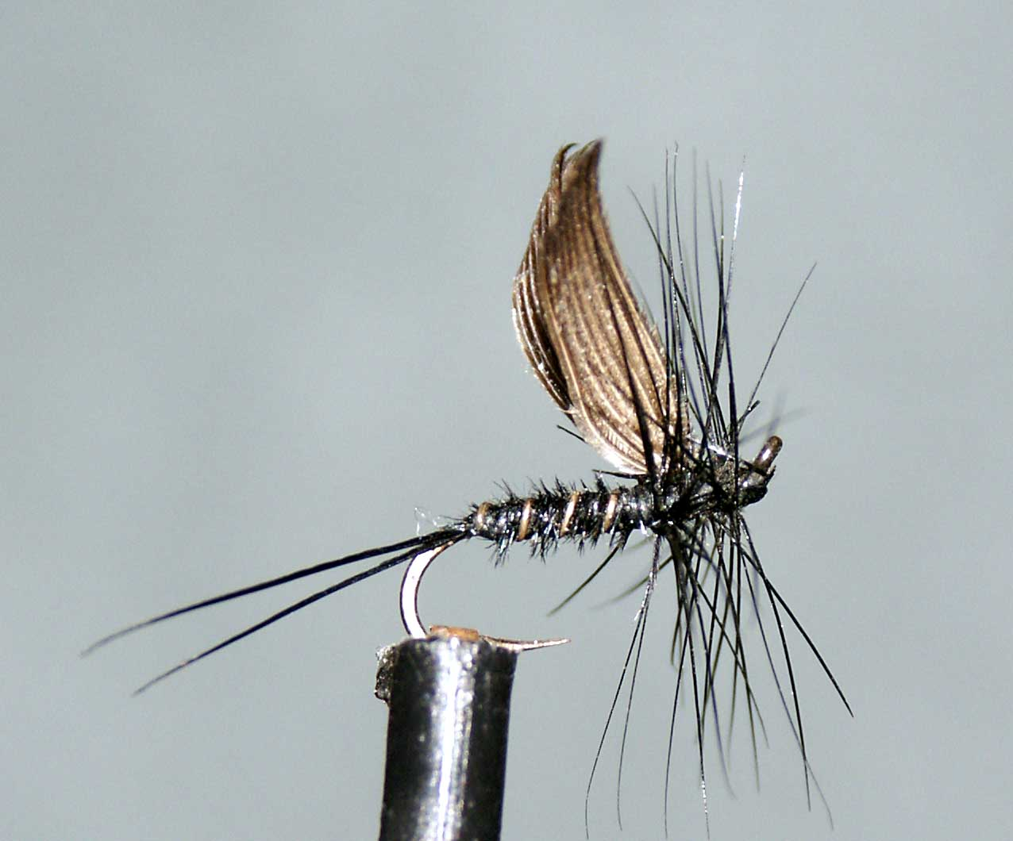

Materials
Dry-Fly hook size 12-18, black thread, black cock hackles, black (dyed) Pheasant tail, Mallard primary wing feather, stripped light game cock hackle stalk.

Tying Sequence
- Attach thread and lay a foundation of approx. 4mm.
- Select a pair of wing slips from matched mallard primary feathers approx. the width of the gape and tie in on top of the thread using the pinch and loop method.
- Lift the wings to the vertical and wind the thread behind the wing to support it. If necessary a turn between the wing slips will hold them apart.
- Take the thread down to the bend and tie in the tail fibres (black cock hackle fibres or pheasant tail fibres).
- Take a game cock hackle stalk and strip the fibres from it, trim the tip and tie it in.
- Select 3 or 4 black P.T. fibres trim the tips and tie in and wind the body back up the shank to the wing position, tie off and trim.
- Wind the hackle stalk up the body in open spirals to rib the fly, tie off and trim.
- Take a suitable black cock hackle and strip the unwanted fibres from the base and tie it in behind the wing concave side up with the hackle stalk between the wings. Trap the stalk down in front of the wing and return the thread to behind the wing and trim away the stalk.
- Wind the hackle forward with at least 2 turns behind the wing and 3 turns in front. Wind the thread in open turns through the hackle and tie off at the eye.
- Trim away the hackle tip and any unwanted stray fibres before finally whip finishing the head.

