TERRY’S EMERGER VARIANT

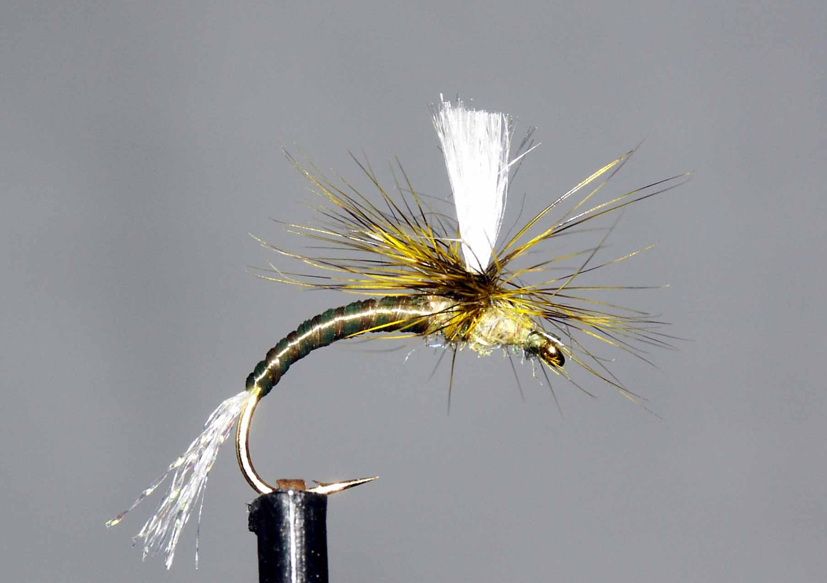

Materials
Size 10-14 buzzer/emerger hook, pearl tinsel/crystal flash, thread to match body colour, clear & body colour flexi-floss, lite-brite/glister, white poly yarn, cock hackle to match.
Tying sequence
- Tie on thread and catch in tinsel and continue to wind down the shank and round the bend. Return thread in open turns to thorax position
- Tie in a wing post to sit vertically and tie in the hackle concave side up to sit by the post.
- Wind the thread around the base of the post tying in the hackle and continue up the post approx 2mm. Return the thread to the base of the post.
- Tie in the two lengths of flexi-floss and continue to bind these materials down the body and around the bend whilst stretching the floss to reduce the bulk.
- Return the thread to the wing position and trim any excess.
- Stretch the two flosses and wind the body up the shank in touching turns, gradually releasing the tension as you go to achieve a tapered effect. Tie off securely at the wing position.
- Dub on some glister/lite bright and wind a thorax both sides of the base of the wing and make sure the thread ends up adjacent to the wing post.
- Wind the hackle around the post making each turn sit below the previous one.
- Secure the hackle with turns of thread around the base of the post and trim away any waste.
- Finish the fly with a little more dubbing if required before finally whip finishing the head.

