**CHILTERN FLY TYING & FLY FISHING**

**WHITE SNAKE**

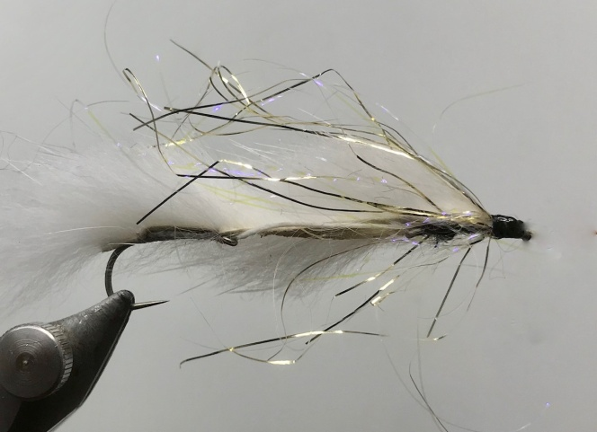

Materials:

Hanak H250 BL size 6 & 8 or similar heavy weight large gape hooks; Ultimate tying silk (Fish on Productions) white and black; dyed white mink or rabbit zonker strip; white 15/20lb braided fly line backing; sparkle glister or similar; uv resin or acrylic paint eyes in white and black.

Tying Instructions:

1. Place the smaller hook in the vice and run the thread down to the bend and back up the shank to the eye.
2. Insert the braid through the eye of the hook then put some superglue on the shank and bind the braid down under the hook shank to the start of the bend then pull the braid up on top of the shank and and continue to bind down to the eye position. Cut off the waste and return the thread to the start of the bend.
3. Select a suitable length of the zonker strip and dampen the fur approx 8-10mm from end of the strip and pull the fur forward to expose the leather. Tie this in at the thread position with 4 or 5 turns of thread.
4. Pull the zonker strip back over the bend of the hook and bind down up against the leather then run the silk back to the eye position in close touching turns.
5. Pull the zonker strip over the shank and measure off where the strip needs to be tied in and dampen the fur to part.
6. Apply a thin bed of superglue over the thread of the shank and then tie in with 4-5 turns of thread where the fur has been parted. When the glue has dried whip finish the thread, trim and remove from the vice.
7. Place the larger hook in the vice and wind the black thread down the shank to the start of the bend.
8. Insert the braid through the eye of the hook and take 2 turns of thread around the braid to hold in position, then pull the braid to the right length, apply some superglue to the shank then bind the braid down to the eye with the thread.
9. Pull the end of the braid back firmly then continue to bind down to the start of the bend where you can trim the waste and return the thread 3mm back from the eye.
10. Pulling the braid tight measure the zonker strip loosely to length and part the fur at this point using dampened fingers.
11. Apply some superglue to the thread and tie in at this point with 4-5 turns of thread, when dry the zonker strip can be trimmed.
12. Tie in a few strand of the sparkle either side of the body to extend to the length of the fly, and then trim the waste.
13. Create a large head with the thread then whip finish.
14. Varnish or uv resin the head before painting on the eyes. When dry, apply a further coat of varnish/resin to finish
15. Cut the hook at the bend of the forward hook.