**CHILTERN FLY TYING & FLY FISHING**

**J C sub DIAWL BACH**

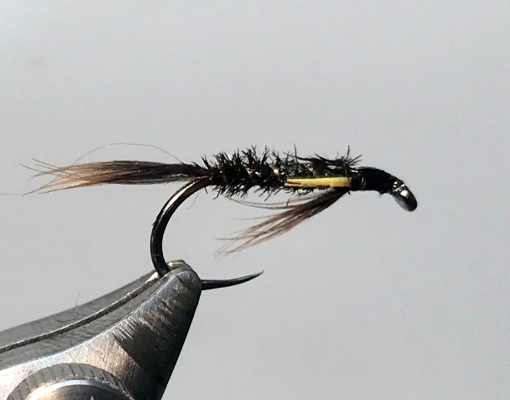

Materials:

Wet fly hook size 10 & 12 ; black thread; natural peacock herl ; sunburst yellow goose biots; dark game/coch y bonddu hen hackle; copper wire rib.

Tying Instructions:

1. Place the hook in the vice and run the thread for 2-3mm.
2. Select a small bunch of hackle fibres and tie in underneath the shank with the tips pointing over the eye about 8mm long then wind the thread down the shank binding the down the waste fibres until you reach opposite the hook point.
3. Select a small bunch of hackle fibres for the tail and tie in with the fibres extending approx 2/3 rds the length of the shank.
4. Tie in the copper rib material at the tail position then select a peacock herl with short flue (fibres) and tie this in at the same position.
5. Return the thread to behind the hackle position in close touching turns binding down the ribbing and peacock.
6. Apply a small amount of superglue or varnish to the shank and carefully wind the peacock herl up the body in touching turns. Tie off at the thread position behind the hackle and remove the waste
7. Wind the ribbing in the opposite direction to the peacock herl and tie this off at the same position.
8. Rotate the hook in the vice and pull the hackle fibres back and wind the thread up against them so that they splay out at about 45 degrees.
9. Return the hook to the normal position in the vice and wind a small head up to the base of the hackle.
10. Select 2 goose biots and trim the pointed tips and tie in one by one, concave side in, one each side of the body at the head position trying not to wind the thread over the throat hackle.
11. When you are satisfied with the position of the biots bind them down firmly so that you can pull on the waste to remove it rather than cutting as this tends to leave a small stub.
12. Finally whip finish and varnish the head.