**CHILTERN FLY TYING & FLY FISHIG**

**LINDSAY’S DABBLER**

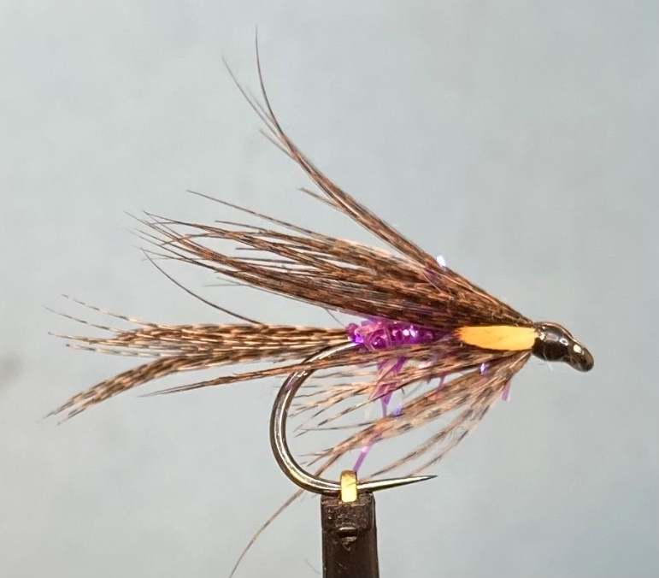

Materials:

Wet fly hook size 8 (Hanak 260BL Wet Fly); black thread (Semperfli Nano silk 50D); bronze mallard shoulder feathers for tail and wing; purple straggle fritz body (Semperfli Straggle String purple); jungle cock hackle feather or goose biot eyes.

Tying Instructions

1. Apply a thin smear of superglue to the shank and catch in the thread and wind a foundation down to a position opposite the hook bard.
2. Select a bronze mallard feather and align the tips of a slip approximately 15mm wide by gently pulling the fibres at right angles to the stem. Cut this slip off and fold in half so that the dark fibres are on the outside.
3. Offer this slip up to the hook so that the fibres extend about 11/2 times the shank length and tie on top of the hook shank with a pinch and loop. If you are happy with the position continue to bind down the waste to secure then trim at an angle, bind down the waste then return the thread to the tail position.
4. Take a length of the body material and strip away the fibres of the straggle to expose the core. Tie this in then wind the thread forward to approximately 3mm back from eye.
5. Wind the straggle in touching turns up the shank stroking back the straggle fibres as you go. Finish 2mm back from the eye.
6. Turn the fly in the vice (or rotate the vice) and then select another slip of mallard feather similar in size to the tail and fold it the same as for the tail.
7. Offer this slip up so that the fibres extend beyond the hook point and tie in on the near side of the hook shank and rotate the slip so that the fibres cloak the shank. Once you are happy with the position bind down the waste then trim.
8. Turn the hook back and bind down any stray fibres to form a base for the wing.
9. Select another mallard feather and prepare a slip for the wing in the same manor as before making this slip about 25mm wide. Fold in thirds.
10. Offer this up to the hook so that the length is about 10mm longer than the body. Try to veil the hook shank with the wing by holding the wing slip on top of the shank with one hand whilst the other hand pushes down on the wing either side of the shank. Wind the thread round with a couple of turns whilst still holding the wings. Once the wing is secure you can check positioning of the wing.
11. Once you are happy with the position take a couple of turns on top and then under the wing to secure.
12. Trim the waste and bind down any stray fibres
13. Select a single jungle cock feather and separate the feather at the centre and offer this up either side of the wing.
14. Tie this in to form ‘eyes’ either side of the wing and bind down the waste.
15. Trim the feather and form a neat head before whip finishing and varnishing the fly.