**CHILTERN FLY TYING & FLY FISHING**

**LEE’S WOOLLEY BUGGER (COMPETITION LEGAL)**

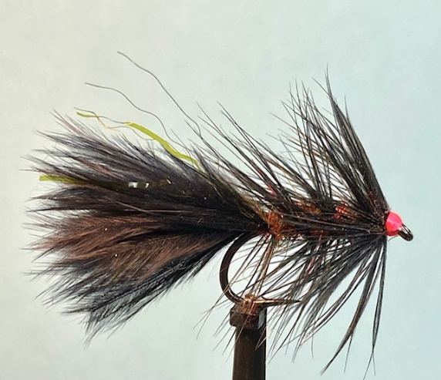

Materials:

Heavy traditional hook size 10 (Kamasan B175); black marabou; fine dark olive flashabou or similar; black genetic hen hackles; clear mono ribbing (5 or 6 lb); dark olive seal’s fur and a pinch of red seal’s fur; hot pink thread (UTC 70 den).

Tying Instructions:

1. Place the hook in the vice and wind the thread onto the shank and continue to the bend.
2. Select a bunch of marabou fibres align the tips and peel off the stalk.
3. Trim the waste ends then pinch out the flue of the marabou to expose the core fibres to a length of the hook shank and offer these up to the shank.
4. Tie these core fibres in at the tail then bind down the waste ends towards the eye making sure that you do not extend beyond a point 2mm behind the eye. Return the thread to the bend and take 2 or 3 turns of thread wraps under the marabou to slightly lift the fibres (to try and prevent the tail wrapping round the hook when fishing).
5. Pinch the marabou tail fibres to length to fit a competition gauge (15/16 inch).
6. Take 2 strands of the flashabou and tie in either side of the tail, trim to the length of the tail then return the thread to the eye.
7. Select a hen hackle that is long enough to palmer wind the length of the body and whose fibres are not much longer than the gape of the hook. Remove the waste material at the base of the stalk and offer up to the hook behind the eye with the concave side uppermost (good side facing down), the tip facing away from the hook
8. Tie this in making sure there is a slight gap between the start of the hackle fibres and thread then wind down the waste end trimming if necessary and finish the thread at the bend.
9. Take a length of the mono and crimp the end with your teeth and tie in then bind own the waste end to secure, then return the thread to the bend.
10. Take a pinch of the colour blend of seals fur and dub it onto the thread to form a tight rope then wind this up the shank in touching turns to form a neat tight body. Finish the body just behind the hackle, pull any remaining seals fur off the thread and bind down any waste.
11. Make sure the ribbing is on the front side of the vice and attach hackle pliers to the tip of the hackle.
12. Pull the hackle stalk towards the bend of the hook and crease it at the point it was tied in then take a full turn of the hackle at the collar before winding down the shank in open even spirals to the bend. If the hackle is not long enough omit the full turn at the head.
13. Still holding the hackle tip at the bend take the mono ribbing and trap the hackle tip in at the bend then continue to wind the ribbing firmly in open even spirals back up the shank weaving the mono back and forth to avoid trapping too many fibres. (You can let go of the hackle pliers once the hackle is secured).
14. Tie off the ribbing and secure then remove the waste hackle tip from the rear of the hook.
15. Select another hen hackle that has a lot of webby fibres (usually found at the sides of the cape) and strip away unwanted fibres so that the remainder of the hackle is at least 1 ½ times the hook gape. Tie in at the stalk at an angle with 2 tight turns in front and pull the stalk back then tie in again before removing the waste stalk.
16. Wind 2 turns of the hackle pulling back the fibres to ‘double’ the hackle fibres, then secure with 2 tight thread wraps
17. Whip finish the thread at the head to form a ‘hot spot’ and trim the thread before removing the waste hackle tip
18. Finally varnish the head. When dry double check that the fly fits the competition gauge