**CHILTERN FLY TYING & FLY FISHING**

**GRAYLING FIDDLER**

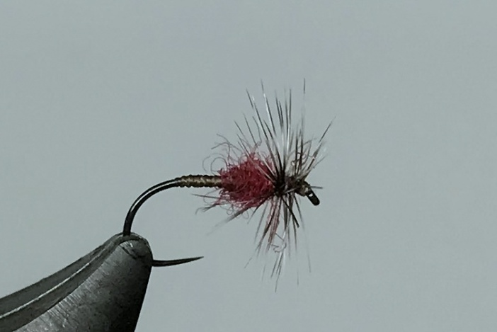

Materials:

Large gape dry fly hook size 16-20; dark brown thread; Davey Wotton Masterclass 20 ‘midge red’dubbing, teased out red wool or red seal’s fur; small grizzle cock hackle.

Tying Instructions:

1. Place the hook in the vice and run the thread down to the start of the bend.
2. Return the thread back up the shank about 4/5 turns depending on hook size, this is left exposed
3. Sparsely dub the thread with the red dubbing then wind a tapered body leaving enough space for the hackle and return the thread to the eye position.
4. Prepare a small grizzle hackle making sure the fibres are about the length of the hook gape and tie this in concave side uppermost and tied in just behind the eye with the stalk projecting back down the shank.
5. Wind the thread back to the dubbing position and trim the hackle stalk waste.
6. Wind the hackle back towards the thread position and tie off the hackle at the thread position then wind the thread through the hackle to the eye position.
7. Hold the tip of the waste hackle and using the ‘crook’ of the scissors, push onto the hackle stalk to cut. Alternatively use a scalpel or sharp blade to cut the hackle **do,not** use scissors that may cut some of the hackle fibres.
8. Wind a small head in front of the hackle making sure that you don’t flatten any hackle fibres.
9. Varnish the thread before applying the whip finish to avoid getting varnish on the hackle, alternatively use a hackle guard.