**CHILTERN FLY TYING & FLY FISHING**

**TOM’S PEARL CORMORANT**

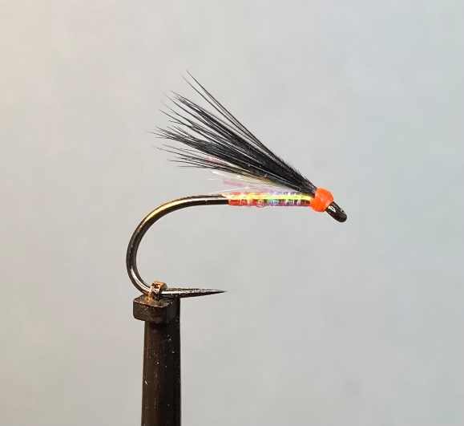

Materials:

Short shank size 10 black nickel (Fario Competition Special FBL 302); fluorescent red thread; medium pearl mylar (UTC Mirage Opal) body; pearl (Angel Flash) underwing; black marabou ‘bloods’ wing.

Tying Instructions:

1. Place the hook in the vice and run the thread down to a position opposite the hook point.
2. Catch in the pearl body material with a couple of turns of thread then return the thread to the eye position.
3. Apply a smear of superglue or varnish to stabilize the body material and then wind the pearl up the shank in touching turns to the thread position and tie in approximately 2mm back from the eye.
4. Take 4 or 5 strands of the pearl underwing material and tie this in on top of the shank with a pinch and loop then trim it to the length of the body material.
5. Select a small bunch of the marabou feather tips (bloods) and offer them up so that the tips cover the underwing and extend
6. Trim the waste marabou to this length then tie the wing material in on top of the shank with a pinch and loop.
7. Bind a small neat head to cover any waste material then finally whip finish and varnish.