**CHILTERN FLY TYING & FLY FISHING**

**TRADITIONAL WET FLY**

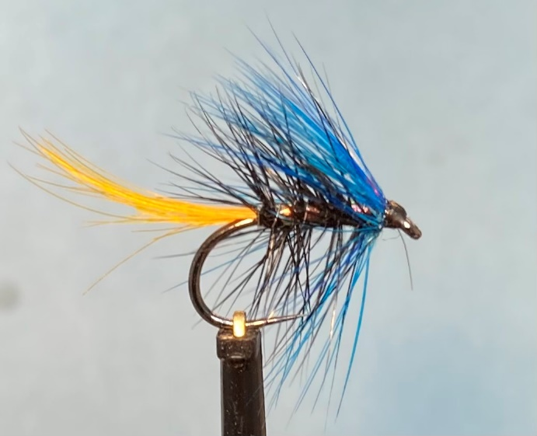

Materials:

Standard shank size 10 ( Hanak 260 BL0; black thread (Semperfli Nano silk 50D); red dyed golden pheasant crest tail; fine silver wire rib (Semperfli 0.1mm); fine pearl tinsel body (Semperfli Mirror tinsel 1/32); black dyed grizzle cock hackle palmer; blue dyed cock hackle collar.

Tying Instructions:

1. If using fine lightly waxed or unwaxed thread, a thin coat of varnish or super glue will stop any dressing from slipping on the hook shank.
2. Place the hook in the vice and tie in a foundation of thread to a point opposite the hook barb.
3. Select 2 suitable sized crest feathers and tie in on top of the shank concave side up, slightly longer than the hook length. Bind down the waste and trim leaving a 3mm gap back from the hook eye.
4. Return the thread to the tail position and tie in a suitable length of the wire ribbing and a length of the body tinsel.
5. Apply a thin smear of varnish or super glue to the shank and wind the tinsel up the shank in slightly overlapping turns finishing 2mm behind the eye.
6. Select a suitable sized black hackle and trim the length so that the mid fibres are about 1½ times the gape of the hook. Strip a few fibres of the hackle to expose the stalk
7. Apply some dubbing wax to the thread and tie in the stalk of the hackle concave side down and bind down the waste to secure and avoid the hackle stalk from pulling out.
8. Attach a pair of hackle pliers to the tip and pull the hackle forward to crease the hackle stalk so that it sits vertically to the shank. Take one full turn of the hackle before winding down the shank in open even turns towards the tail position.
9. Keeping tension on the hackle, take the wire rib and secure the hackle with one turn of the ribbing. Let the hackle waste rest on the vice or dangle before winding the rib back up the shank in open even turns to the thread position weaving the ribbing back and forth to try and avoid trapping too many hackle fibres.
10. Tie off the ribbing 2mm back from the eye and ‘worry’ off the excess. Remove the waste hackle.
11. Select a suitable collar hackle approximately 11/2 – 2 times the hook gape and strip away the base fibres.
12. Apply a little wax to the thread before tying in the hackle stalk to secure.
13. Attach the hackle pliers to the tip of the hackle, pull forward to crease the stalk, then wind 3 full turns of hackle forward trying to avoid trapping any hackle fibres that face forward.
14. Secure the hackle stalk then pull any stray fibres back and bind down in front of the hackle. Whilst still holding the hackle fibres build a neat head.
15. Whip finish the thread and remove the waste hackle stalk before applying the varnish.