GREENWELL’S GLORY
WET FLY

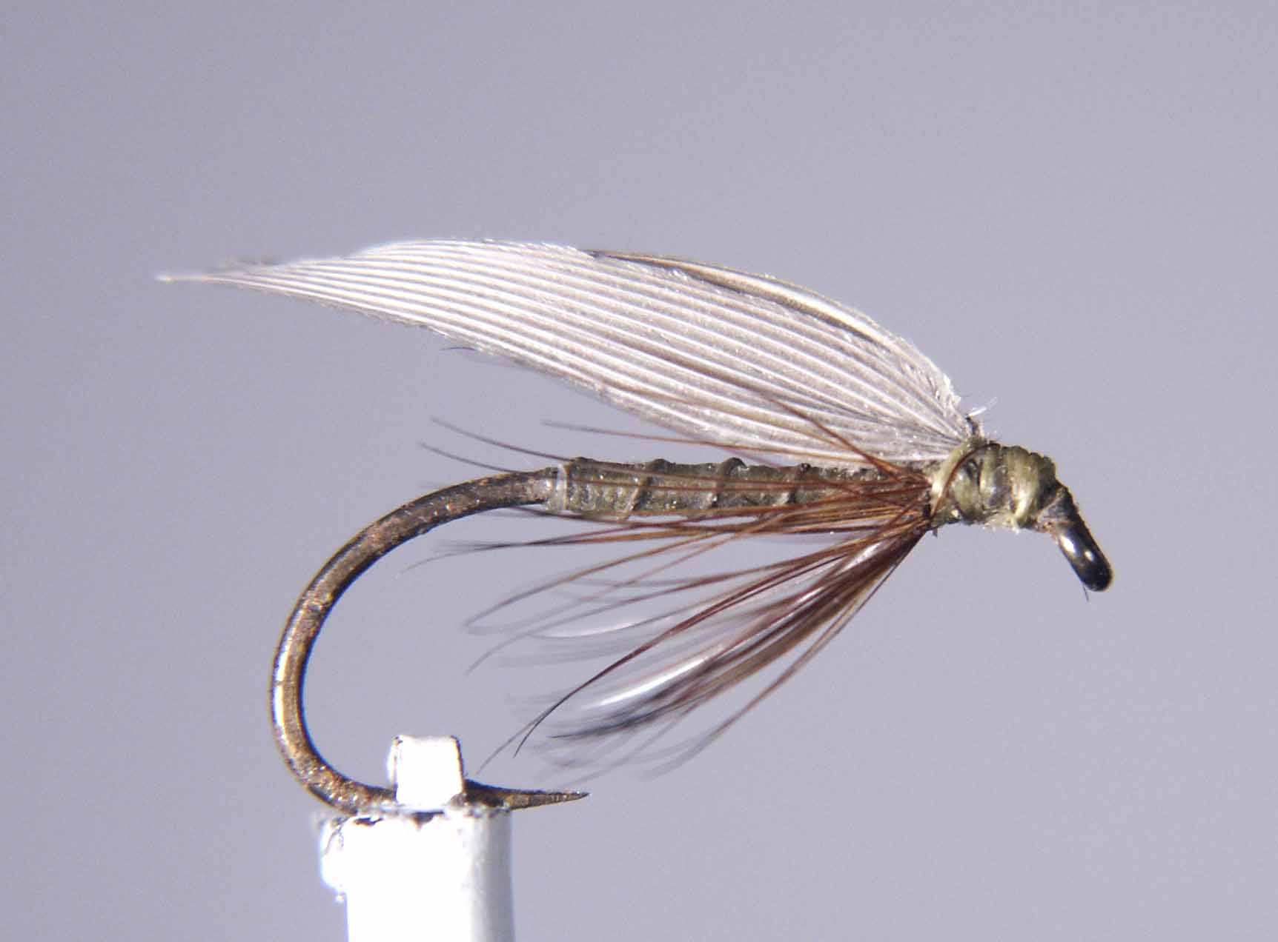

Materials
Std wet-fly hook size 10-14, waxed primrose thread (olive), gold wire, furnace/cock-y-bondu hackle, Mallard primary wing feather.

Tying sequence

- Wax the thread/silk to give a dirty olive colour and tie onto the hook shank.
- Wind the thread in touching turns down the shank to the start of the bend.
- Tie in the gold wire and with the well-waxed thread wind a tapered body finishing with the thread at the eye.
- Rib the body with the gold wire in open even spirals and tie off approx 4 mm behind the eye .
- Select a suitable hackle and tie in concave side down and bind down the stalk and trim.
- Wind a collar hackle with 2 turns and tie off and trim.
- Pull all of the hackle fibres on the top and at the sides of the shank so that they sweep under the shank. Trap these down with turns of thread and prepare a foundation for the wing with the thread.
- Select a pair of wing slips from the mallard primary feathers (matched pair), place them concave sides together with the tips aligned.
- Tie them on top of the shank with the pinch and loop method (the wing slips can be tied in either with the slips sweeping up or down).
- Remove the unwanted fibres by cutting parallel with the hook eye and bind down with thread to form a small neat head.
- Finally whip finish and varnish the head.

