**CHILTERN FLY TYING & FLY FISHING**

**SOFT HACKLE LARGE DARK OLIVE**

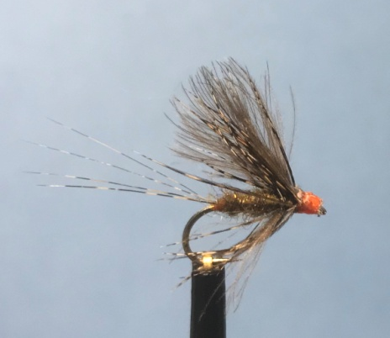

Materials:

Light wire 2X hook size 14 &16; orange thread 8/0 or finer; coq de leon hackles or stiff brown hackles; brown olive synthetic dubbing (life cycle or Partridge SLF Masterclass blend no 1; natural brown cdc feathers; brown partridge body hackles.

Tying Instructions:

1. Place the hook in the vice and tie on the thread and wind down to opposite the hook point.
2. Select a small bunch of the hackle fibres (2-4) and tie on top of the shank extending 1 ¼
3. times the shank length. Continue binding down the fibres to the start of the bend then take 2 turns underneath the tail fibres to splay and ‘cock’ the fibres up. Trim the waste fibres just back from the eye.
4. Dub on the olive brown dubbing then wind a small tapered body 2/3rds up the shank. Remove any excess and wind the thread forward 2mm.
5. Select 2 cdc feathers that are no longer than the length of the body plus the tail and place the feathers either side of the hook with the stalks pointing down below the shank at the point where the thread is. Take 2 turns of thread around the cdc and shank then pull gently down on the stalks until the cdc fibres bunch up to form the wing. When you are satisfied with the height and position bind down the waste ends, trim and return the thread to behind the wing.
6. Prepare the partridge hackle by removing all of the soft downy fibres from the stalk then place the very tip in some hackle pliers and stroke as many of the hackle fibres as you can back towards the stalk.
7. With the concave (dull) side of the hackle facing down tie in the tip of the hackle at the back of the wing then wind the thread forward binding down the tip, remove the waste.
8. Grip the hackle stalk in a pair of hackle pliers and take 1 full turn behind the wing stroking back the hackle fibres, then make a further 2 turns in front of the wing continuing to stroke the hackle fibres back. Secure the hackle stalk with turns of thread then remove the waste.
9. Wind a neat prominent head up against the hackle trying not to flatten the flair of the hackle then varnish the thread and whip finish.