GOLDEN BROWN

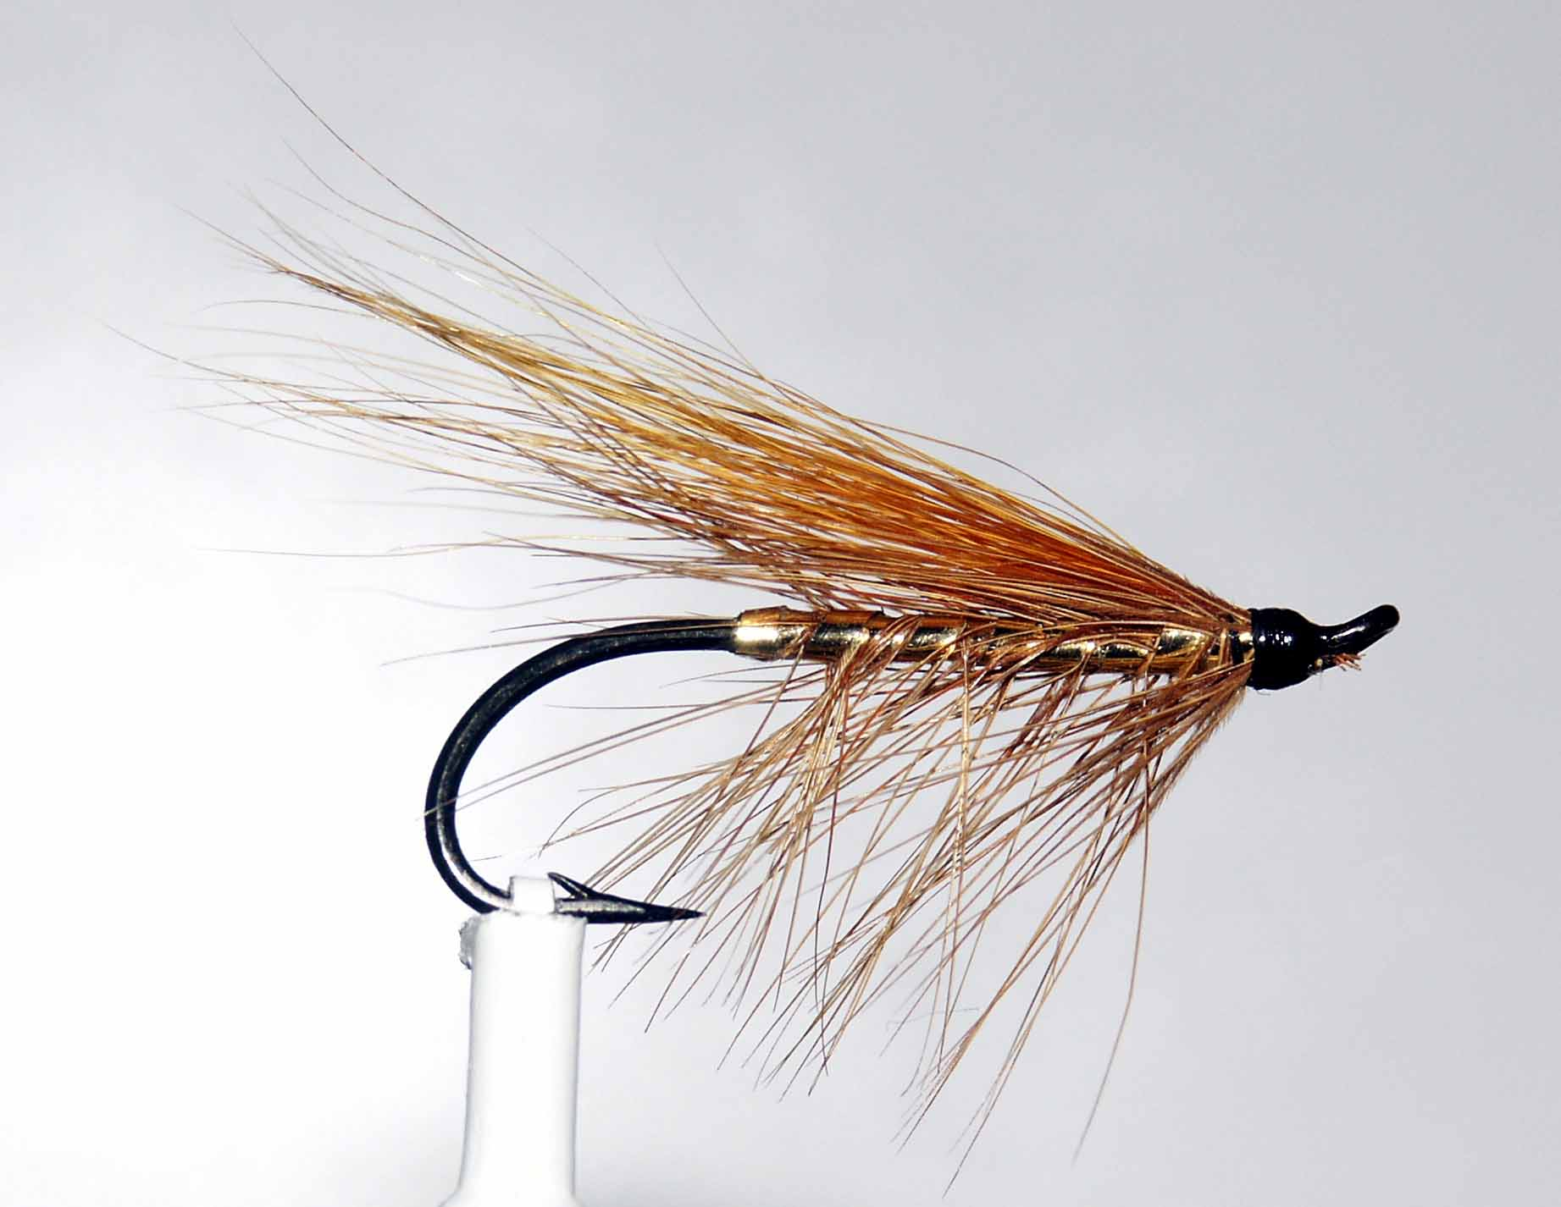

Materials
Hook: single/double sizes 6-12, black thread, gold mylar/lurex, game cock hackle, light brown squirrel/calf tail.

Tying Sequence
- Catch in the thread and wind a foundation 2/3 down the shank.
- Tie in the hackle by the tip and return the thread to approx 4 mm back from the eye, trapping the hackle tips as you go. Tie in the gold body material and leave the thread at this position.
- Wind the body in tight touching turns down the shank to the hackle position.
- Double the hackle around the gold and wind back to the wing position in open even spirals and tie off and trim.
- Select a small bunch of suitable wing material and align the tips by using a hair stacker.
- Tie in the wing securely and trim the excess at an angle and apply a small drop of varnish/superglue to the base of the wing before binding down.
- Finally whip finish and apply two coats of varnish to create smooth glossy head.

