**CHILTERN FLY TYING & FLY FISHING**

**SLOW SINKING SHRIMP**

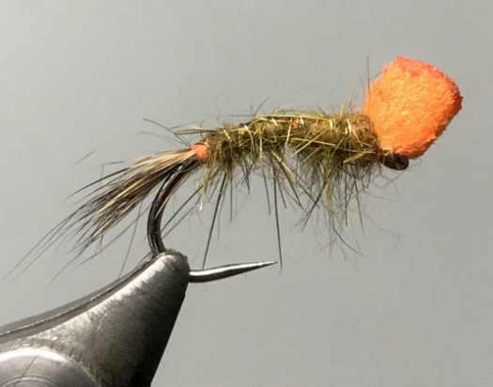

Materials:

Heavyweight buzzer hook size 10; orange thread; 4mm yellow foam cylinder; winter rabbit skin; thin gold or silver wire; Bronze holographic tinsel shellback; killer shrimp dubbing mix.

thin Tying Instructions:

1. Place the hook in the vice and tie on thread and wind down to a position opposite the point of the hook.
2. Prepare the foam cylinder for tying in by cutting at an acute angle and slitting the foam down the length of the angled cut. The length of the tapered foam should be approximately the length of the foundation thread.
3. Tie in the foam tip and bind down the foam as you wind back to the eye position being careful not to cut through the foam by putting too much pressure on the thread.
4. Return the thread to the start of the bend.
5. Take a good bunch of the rabbit fur and remove all of the grey under fur leaving just the guard hairs and tie these in to form a tail which should wrap slightly around the bend. You can change the angle of the hook in the vice to make this easier.
6. Return the thread to the start of the bend position and tie in the wire and then the shellback material. Take 2 turns of thread to create an orange tag.
7. Dub on a generous amount of the killer shrimp dubbing mix and wind a fairly bulky body back to the foam cylinder.
8. Pull over the shell back material and tie off, then rib over the body in the opposite direction to the dubbing. Tie off and remove the waste wire and shell back.
9. Dub on a small amount of the body mix and wind over the ends of the shell back and wire.
10. Whip finish and varnish the head and brush down the dubbing to simulate legs.
11. Trim the foam to a length so that the fly very slowly sinks in the water – this is by trial and error.
12. When the foam is trimmed and dry paint with neon orange acrylic or sharpie pen.