BRISTOL RAIDER

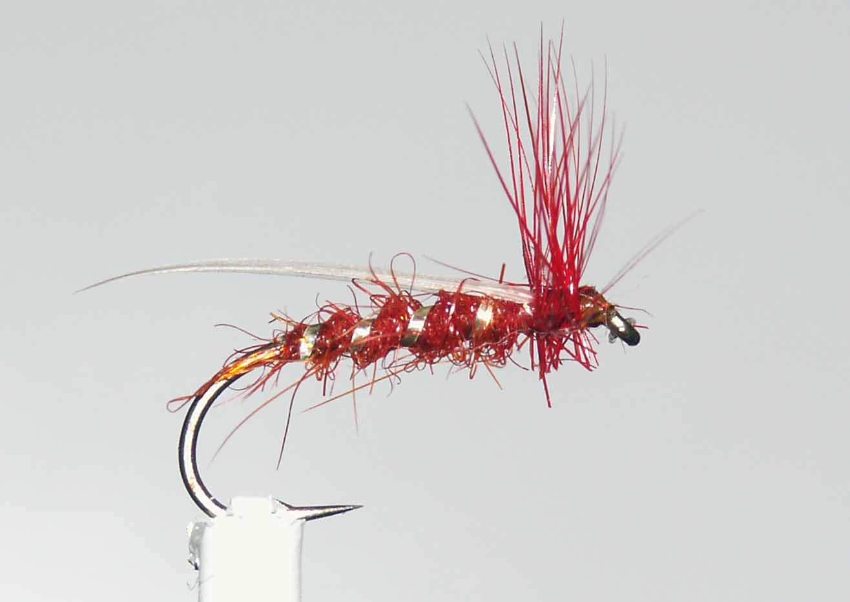

Materials
Light wire hook 10-14, silver tinsel rib, suitable colour thread, seals fur and cock hackles, white swan / goose biot.

Tying Sequence
- Tie on the thread and catch in the silver tinsel and continue to wind down the shank to the start of the bend binding in the silver tinsel as you go.
- Dub on to the thread the seal’s fur and wind a tapered body catching in as many of the fibres as you can, finish 4mm behind the eye.
- Wind the silver ribbing in open even turns up the body and tie off at the end of the body and trim the waste.
- Select a white swan/goose biot and tie this on top of the shank at the wing position to extend just beyond the length of the hook
- Select a suitable cock hackle and tie this in by the base of the feather concave side facing towards the eye and wind it forward.
- Wind the thread through the hackle and tie off and trim the hackle.
- Finally whip finish and varnish the head and trim the underside of the hackle.

