**CHILTERN FLY TYING & FLY FISHING**

**SUPA PUPA**

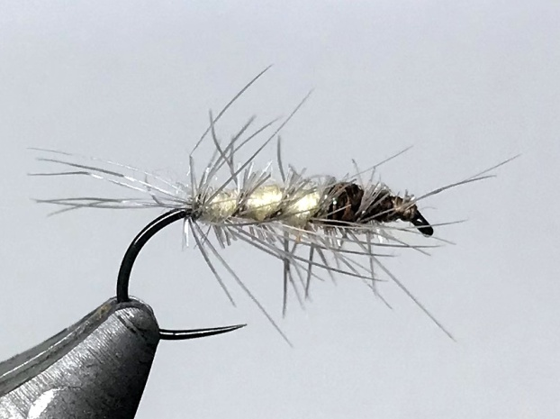

Materials:

Dry fly hook size 14-20; thread to suit body and thorax colour; fine pale cream dubbing e.g. Superfine Pale Cream; fine dark brown dubbing. Alternative colour combinations are light and dark olive and grey and black; Blue Dun saddle hackle; optional ribbing of 4lb clear mono or fine silver wire

Tying Instructions:

1. Place the hook in the vice and wind the thread down the shank to the start of the bend.
2. Crimp the end of the clear mono and tie in at the bend and wind the tread back to secure the rib then return the thread to the bend, flattening the thread will help to reduce the bulk. Alternatively tie in the silver wire.
3. Tie in the blue dun hackle by the tip concave side down
4. Dub on the body colour and wind a slim tapered body to 2/3 the shank length.
5. Remove any surplus body dubbing then apply the thorax dubbing.
6. Wind the thorax to the eye position and remove any surplus.
7. Grip the hackle stalk with hackle pliers if it’s too short then wind the hackle up the body to just behind the eye in open even turns (5-6 turns depending on hook size), then tie off and trim.
8. If a ribbing is used then wind this up the shank in the opposite direction in open even turns weaving the mono back and forth so as not to trap too many hackle fibres.
9. Tie off the ribbing behind the eye and trim the waste before winding a small neat head.
10. Whip finish and varnish in the usual manner.
11. When the varnish is dry trim the hackle on top and underneath the fly so that it can sit in the surface film when fished.