GREY WULFF

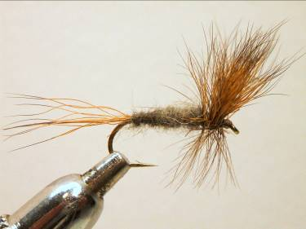

Materials
Light wire size8-14, brown thread, natural brown bucktail, blue dun cock hackle

Tying Sequence
- Tie on the thread and wind a foundation of approx. 5 mm.
- Prepare the bucktail by cutting from the skin a largish bunch of fur. Remove as much fluff and underfur and place the tips into a hair stacker. Tap the stacker until all the tips are aligned.
- Remove the hair from the stacker and tie on top of the shank with the tips pointing forward approx. ½ to 2/3rds the shank length. Secure with firm turns of thread and then pull back the wing and wind several turns of thread in front to hold the wing up.
- Return the thread to behind the wing and bind down over the butts; a drop of varnish at this stage over the body will help to secure the hair fibres. Trim the waste fibres at an angle to form a taper to the body and continue binding down the butts till you reach the bend.
- If the wing is to be separated then return the thread back to the wing in open turns and use a figure of eight to separate two bunches of hair.
- Return the thread to the bend and tie in a bunch of bucktail for the tail and bind down the butts before returning the thread to the bend.
- Dub on some rabbit underfur and wind a body up to the wing position and tie off.
- Select a blue dun cock hackle and tie this in behind the wing with the stalk separating the hair wing. Bind down the stalk and trim then return the thread to behind the wing.
- Wind the hackle behind the wing with 2 full turns then in front with 3 full turns, bring the thread forward through the hackle in open turns trying not to trap too many fibres then tie off and trim.
- Finally whip finish and varnish the head making sure you don’t soak the hackle or the wing.

