**CHILTERN FLY TYING & FLY FISHING**

**LEE’S QUIRKY DIAWL BACH**

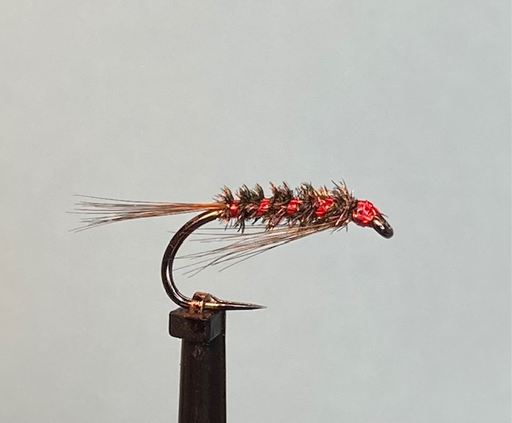

Materials:

Black competition heavyweight hook size 12 (Fulling Mill FM15 13); Greenwell/light Furnace cock hackle fibres;

Small red holographic tinsel (spool in a bobbin holder); Peacock herl; black thread (UTC 70 den).

Tying Instructions:

1. Place the hook in the vice and wind the thread onto the shank and secure the thread and return to approximately 3 mm behind the eye position
2. Take a suitable sized cock hackle and strip away any unwanted fibres at the base of the stalk then hold it by the tip with the right hand (for right-handed tyers). Select a bunch of the cock hackle fibres with the left hand on the left side of the stalk and pull out at right angles to align the tips.
3. Peel off the stalk in a downward movement and offer up to the hook so that the tips extend to the left of the eye approximately the distance from the hook point to the thread position. (3 mm back from the eye).
4. Tie in at this position and check for length before winding 2 turns towards the eye to trap the fibres in.
5. Tease the fibres either side of the shank and with thread wraps position the fibres to point down on both sides of the shank the last thread wrap should be no less than 1 mm behind the eye.
6. Trim the waste at an angle to avoid a step in the material and continue to wind the thread to the start of the bend.
7. Take the cock hackle this time holding the tip with the left hand. Select another bunch of cock hackle fibres this time from the right side of the stalk, align the tips and peel off the stalk and offer up to the shank so that the tips of the fibres extend by the length of the hook shank.
8. Secure with 2 turns of thread wraps then check for length and adjust, if necessary, then trim the wase and wind the thread forward to bind down any waste.
9. Take the red holographic tinsel and tie in and secure on the far side of the hook and continue to wind the thread to the tail. Park the bobbin holder out of the way.
10. Take 2 thin strands of peacock herl, trim the tips and tie in at the tail position and wind the thread forward over the waste ends trimming any surplus, if necessary, then leave the thread at the eye position.
11. Apply sparingly any varnish or glue over the shank to reinforce the fragile peacock herl then wind forward towards the eye in touching turns. Tie off behind the eye and trim the waste.
12. Take the bobbin holder with the red holographic tinsel and wind a rib in open even spirals towards the eye. Tie off the tinsel at this position but **do not trim at this stage.** Park the bobbin holder out of the way
13. With the thread at the front of the material behind the eye moisten the fingers and tease the fibres back under the shank and secure trying not to flatten the ‘beard’ hackle. Tidy up any unwanted fibres and varnish and whip finish the thread keeping the area behind the eye as small as possible.
14. Take the tinsel in the bobbin holder and carefully pull off about 150mm (inches), let it hank on the bobbin then untwist the tinsel before **carefully** whip finishing a head. Pulling the tinsel through the whip needs to be done very slowly as the tinsel can break if it is twisted too much.
15. Finally trim the tinsel with a blade then varnish the head.