DAMSEL NYMPH

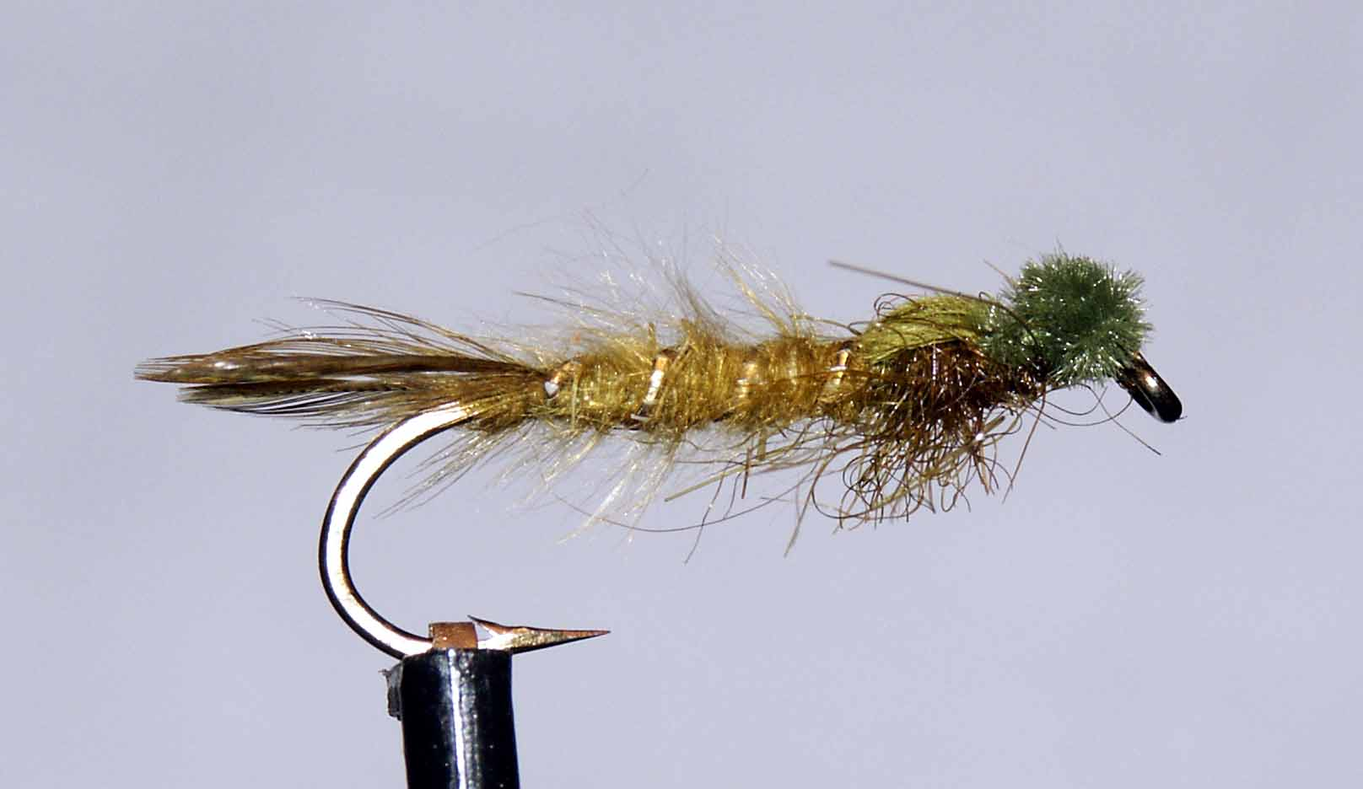

Materials

6-10 long shank hook, olive thread, oval gold tinsel, olive cock hackles, dyed olive swan herl, olive marabou, olive seal’s fur, dark olive/green micro chenille.

Tying Sequence

- Tie on the thread and wind a foundation down to the bend.
- Select 3 small hackle tips and tie on top of the shank to form a ‘Trident’ tail (a small ball of olive dubbing on the shank will help to tie in the tail).
- Tie in the gold ribbing and then dub onto the thread fibres picked off a marabou feather.
- Wind the dubbed thread up the body to approx 1/2-2/3 the shank length increasing the taper of the body as you go.
- Rib this portion of the body and tie off and trim the waste.
- Select a 5mm strip of swan herl and tie in on top of the hook in front of the body, dark side down with the slip of feather extending back towards the tail. The thread should be ia the start of the thorax.
- Dub the thread with seal’s fur and wind a thorax slightly fatter than the body finishing approx 3mm behind the eye.
- Pull over the swan herl to form the thorax cover and tie off but do not trim.
- Tie on the preformed chenille eyes with a figure of eight whipping and pull over the swan herl to lie between the two eyes.
- Finally tie off the swan herl, trim the waste, whip finish and varnish the head.

