INVICTA WET-FLY

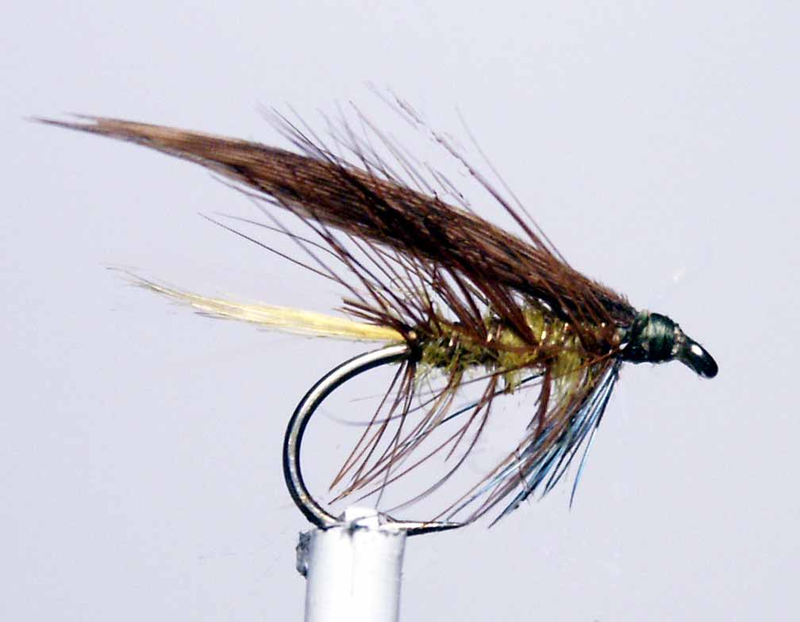
Materials
Standard shank wet-fly hook 10-14, olive thread, golden olive dubbing, oval gold rib, hen pheasant centre tail, golden pheasant crest red game cock hackle, blue jay covert.
Tying Sequence

- Tie on the thread and wind a foundation down to the bend and tie in the gold rib under the shank.
- Select a suitable G.P. crest (topping) and tie in on top of the shank at the start of the bend, with the curve of the crest sweeping up and extending the length of the shank. (saliva can help in keeping the fibres together)
- Dub on the golden olive dubbing and wind a tapered body to within 3mm of the eye.
- Prepare a suitable cock hackle and tie in by the butt, concave side down securing the hackle stalk before trimming the waste. Wind this hackle down the shank in open even turns “palmer style” to the bend where it can be secured by the first turn of the ribbing material.
- Wind the ribbing material in open even turns back up the shank trying not to trap too many hackle fibres. Tie off 3mm back from the eye and trim the waste ribbing material and cock hackle.
- Strip off the blue fibres from the blue jay covert feather and tie these under the shank 3mm back from the eye to extend to the hook point, try to tie in these fibres to the right length so that no trimming is necessary. Using a thumb nail spread these fibres to form a beard hackle.
- Wind a foundation for the wing trapping all loose fibres and leave the thread hanging just in front of the hackle position.
- Prepare a pair of wing slips from the hen pheasant centre tail and tie in on top of the shank using the “pinch and loop” method so that the tips of the wing reaches just beyond the tips of the tail. Once satisfied with the position secure with touching turns forward of the first turn so that you do not disturb the set of the wing.
- Trim the waste feather fibres in line with the angle of the hook eye, wind a neat head and finally whip finish and varnish the head.

