CHILTERN FLY TYING & FLY FISHING

INDICATOR FLY

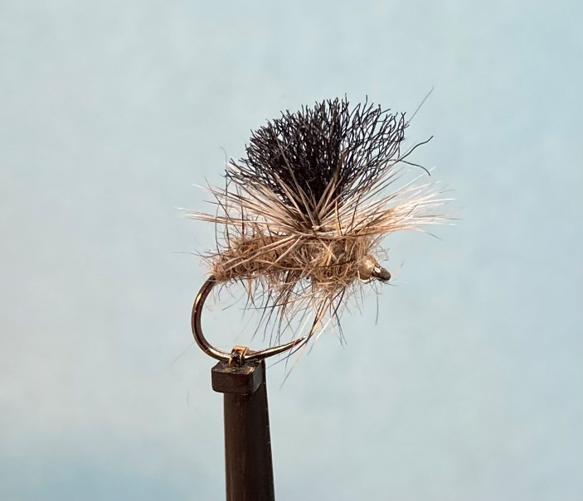

Materials:
Grub hook size 14 (Dohiku 644); tan thread; black (or colour of choice) floating floss; grizzle cock hackle; mix of hare’s ear and fox squirrel guard hair dubbing.

Tying Instructions:
- Place the hook in the vice and run the thread for approximately 4mm.
- Bring the thread back 2mm and pinch and loop a length of floss for the indicator post.
- Secure the post with wraps of thread at the back and front of the post then wind the thread up the post approximately 1.5-2mm then back down again.
- Select a grizzle hackle approximately 1-1/2 times the hook gape and strip out the fluff and lower fibres and trim to a short length of stalk.
- Make sure the thread is at the rear of the post and place the hackle concave side down with the stalk at the back of the post pointing forward behind the post as you look at it.
- Take a wrap of thread at the back to trap the stalk in then wind in front to trap in the tip.
- Holding the hackle up against the post wind the thread around them both then bring the thread down again and continue to wind the thread to just around the bend.
- Taking a pinch of hare’s ear and a pinch of some coarse fox squirrel guard hairs, mix together to form the dubbing.
- Dub this mix onto the thread and wind the dubbing up the shank to the post then wrap the dubbing around the base of the post both in front and behind.
- Place the grizzle hackle into the hackle pliers if needed then wind the hackle in the same plain as the thread wraps (clockwise in most cases) making each turn under the previous turn.
- When the required number of wraps is made pull the hackle down over the shank behind the post (away from you) then you should be able to tie in the hackle on tip of the shank without trapping too many fibres. Continue to hold onto the hackle
- Wind a couple more turns around the hackle.
- Pulling the hackle fibres and the post back wrap further turns in front of the hackle. Carefully trim the waste stalk.
- Apply a small amount of dubbing onto the thread and wind in front of the hackle post whilst still holding it back so as not to trap too many fibres.
- Whip finish a neat head and varnish.
- Before trimming the wing post pull on it and push down the hackle with a curved tool (a whip finish tool)
- Trim the wing length to suit.

