PARCEL TAPE SEDGE

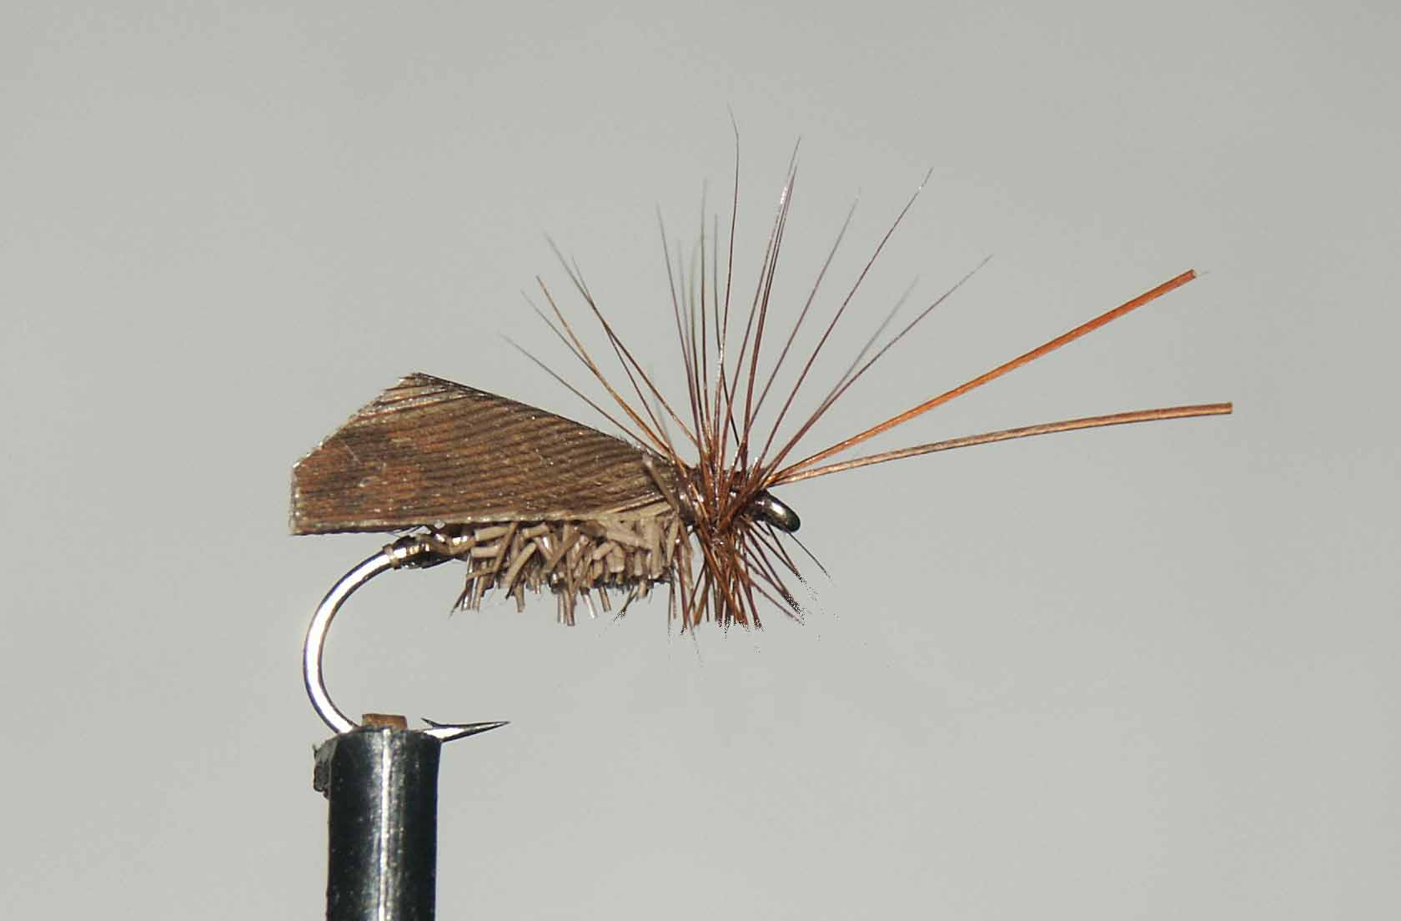

Materials
10-14 light wire hook, brown thread, fine deer hair, grouse body hackle or similar, game cock hackles, brown parcel tape.

Tying sequence

- Run the thread down the shank in touching turns until you reach the bend.
- Form a thread loop making sure you wrap the thread around the loop before returning it to approx 4mm behind the eye.
- Attach a dubbing whirl or similar devise to the loop
- Select a bunch of fine deer hair and remove from the skin and place it between the loops of thread (the use of a bulldog clip aids this) with the butt ends protruding approx.3mm.
- Trim the other side of the deer hair carefully avoiding pulling any of the hair from the loop.
- Holding the thread loop below the deer hair between thumb and forefinger, spin the whirl or twister until you feel the loop tighten.
- Carefully release the pressure between your fingers, and at the same time, gently pull the spun loop with the other hand. This should spin the deerhair.
- Wind this up the shank stroking the deer hair back as you wind.
- Tie off and trim away any unwanted deer hair and slightly taper the top of the abdomen.
- Tie in the preformed wing so that it sits low over the body.
- Select two hackle stalks for the antennae and tie in to point forward.
- Select a suitable hackle and tie in against the wing, concave side facing forward and wind towards the eye.
- Secure the hackle by winding the thread through it before the final whip finish.
- Varnish the head and finally remove the lower hackle fibres to enable the fly to sit low in the water.

