**CHILTERN FLY TYING & FLY FISHING**

**GREY BOY BUZZER**

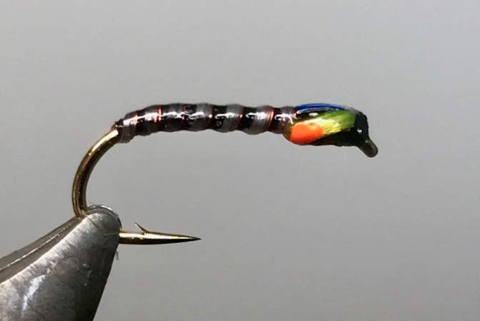

Materials:

Kamasan B175 size 10/12; black thread; white flexi floss; sunburst yellow flexi floss; extra fine red wire; medium opal mirage tinsel; hot orange acrylic paint.

Tying Instructions:

1. Place the hook in the vice and run the thread down around the bend and return the thread to the eye.
2. Tie in a length of white flexi floss securely and pull the floss tight to reduce the thickness and bind down with the thread to the position of the foundation thread just around the bend.
3. Tie in a suitable length of the red wire and return the thread in close touching turns to cover all of the materials, to a position approx 3mm back from the eye.
4. Pull the flexi floss tight and wind a rib in close even turns towards the thread reducing the tension on the floss with each turn so as to increase the thickness of each turn of rib. Aim to get 6 turns on a size 10.
5. Tie off the floss securely and either whip finish or half hitch the thread to prevent the floss from unravelling. Trim the waste
6. With the red ribbing wind each turn so that it sits up to and in front of each turn of floss. Tie off at the thread position and trim the waste.
7. Take a small length of the sunburst flexi floss and tie in beneath the hook by looping the floss around the thread and pulling the loop into position following this with a few turns of thread in front
8. Tie in a short length of the tinsel just above where the floss was tied in so that it sits on top the hook shank. Bind down the waste and then create a shaped thorax with the tying thread, finishing just back from the eye.
9. Reposition the hook angle so that the thread doesn’t slip off when tying off the flexi floss cheeks.
10. Pull the 2 strands of flexi-floss at a 45 degree angle around each side of the thorax under a small amount of tension and bind down on top of the shank just back from the eye, secure with a half hitch or whip finish.
11. Trim the flexi floss by pulling tightly and cutting closely to the thread.
12. Pull over the mirage tinsel and bind down, secure with the thread then trim the waste.
13. Whip finish and trim the thread then coat all over with Helly Hanson or UV lacquer.
14. When dry paint the lower half of the wing cases with the hot orange acrylic using a fine needle.
15. When the paint is dry give everything another coat of Helly Hanson.