**CHILTERN FLY TYING & FLY FISHING**

**FRENCH PARTRIDGE MAYFLY**

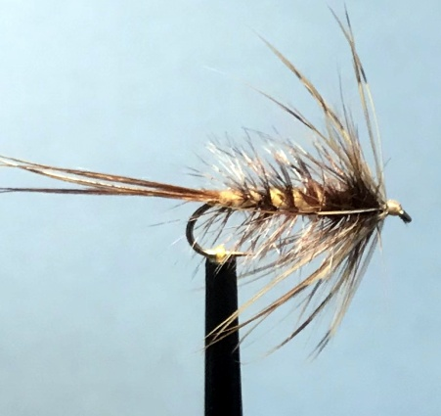

Materials:

4x long shank hook size 12 & 14; tan thread 8/0 or finer; cock pheasant centre tail; fine nylon mono; cream dubbing (fly-rite no 44 Ecru); dark olive brown (fly-rite no42); dark brown/honey brown cock hackle (long hackle); Furnace/dark game cock hackle; French Partridge body hackle

Tying Instructions:

1. Place the hook in the vice and tie on the thread and wind down to opposite the hook point.
2. Select a small bunch of the cock pheasant tail fibres (4-6) and tie on top of the shank extending 1½ times the shank length. Continue binding down the fibres to the start of the bend then take 2 turns underneath the tail fibres to splay and ‘cock’ the fibres up. Wind the thread back up the shank trapping in the tail fibres to approx ¾ shank length. Trim the waste.
3. Crush the end of the nylon mono and tie it in then bind the ribbing back down to the tail position
4. Dub on the cream dubbing then wind a tapered body 2/3rds up the shank. Remove any excess dubbing.
5. Dub on the brown dubbing and wind up against the cream body for approx 2-3mm matching the diameter of the cream body. **You need to have at least 4mm of shank left for the hackles**
6. Select a brown hackle that has fibres approx the width of the hook gape. Strip the unwanted soft fibres from the end of the hackle and tie in up against the brown dubbing, concave side down.
7. Take 1 full turn of hackle in front of the brown dubbing then wind down the shank ‘palmer’ style in open even turns to the tail position creating a segmented body.
8. Using the mono ribbing, trap in the hackle tip at the tail position then wind back up the shank weaving the rib back and forth so as not to trap too many hackle fibres. Tie off the rib where the hackle was tied in. Trim the waste and remove the waste hackle at the tail.
9. Select and prepare a Furnace cock hackle that has fibres approx twice the gape width and tie this in by the stalk concave side down. Using hackle pliers to hold the hackle tip stroke the hackle fibres back as you wind 2-3 full turns. Tie off and trim.
10. Select a partridge body hackle that has fibres at least 3x the gape width and prepare the hackle to tie in by the tip.
11. Tie in the tip of the hackle and bind the thread forward trapping in the hackle. Remove the waste
12. Grip the waste stalk with hackle pliers then ‘double’ the hackle by stroking the fibres either side of the stalk. Wind forward up the shank continuing to stroke the hackle fibres back.
13. Tie off the stalk and trim the waste then wind a neat head up against the partridge hackle trying not to disturb the rake of the hackle.
14. Finally whip finish and varnish the head. Then ‘tease out any trapped hackles with a brush.