CHILTERN FLY TYING & FLY FISHING

LEE’S BLACK & SILVER CRUNCHER

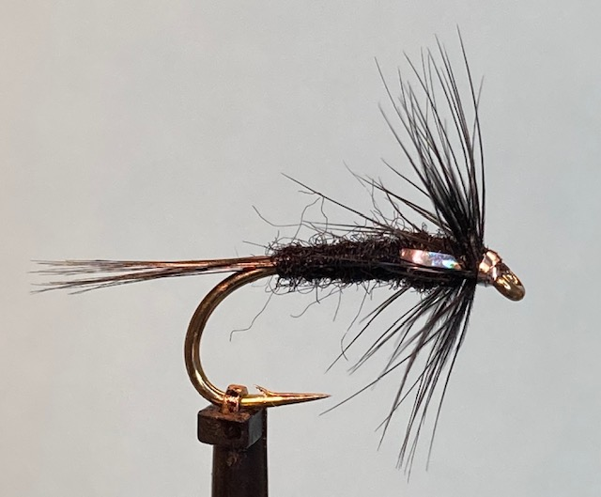

Materials:
Heavy traditional hook size 10 (Kamasan B175); black rabbit dubbing; black cock hackle fibres; black hen hackles; medium/fine silver tinsel (or holographic silver tinsel); black thread (UTC 70 den).

Tying Instructions:

- Place the hook in the vice and wind the thread onto the shank and continue to the bend.
- Select a bunch of black cock hackle fibres on the stalk and pull out at right angles to the stalk to align the tips.
- Peel off the stalk in a downward movement and offer up to the hook so that the tips extend from the start of the hook bend to a length equal to that of the body.
- Tie in at this position and check for length before winding forward to trap the fibres in. Trim the waste at an angle to avoid a step in the material and wrap over. Return the thread to the start of the bend.
- If you want to tie the hackle in first as we did for the Black & Peacock Spider now is the time to do it.
- Take a bunch of the rabbit fur and prepare it the same way as you prepared the hare fur.
- Dub the rabbit fur onto the thread in the same manner as the hare fur and then make the first locking turns to anchor the fur.
- Continue to wind a body of the dubbed fur towards the eye and finish at the eye, remove any waste material then take the thread forward to the back of the thorax position.
- Cut 2 short lengths of the tinsel to form the wing buds then tie these in either side of the shank so that the waste extends towards the rear of the hook making sure that the tinsel is the same position either side of the shank. (a rotary vice makes this very easy).
- Return the thread to the rear of the thorax
- Apply a small amount of the rabbit dubbing to the thread and wind a slim thorax and finish 2mm behind the eye.
- Pull the tinsel wing bud material forward one at a time and tie in and check they match on either side.
- Trim the waste ends and bind down any waste and stray dubbing.
- Select a suitable black hen hackle (hackle fibre length slightly more than the hook gape) and prepare to tie it in by the tip in a similar manner to the hackle tied in on the B&P Spider.
- Tie the hackle tip in with the good side facing down and the waste tip extending over the body. Secure with 2 wraps on top and 1 behind the hackle stalk then pull the tip forward to trap the fibres with 2 more wraps.
- Trim the waste ends then wind the thread forward in front of the hackle.
- Grip the stalk of the hackle with a pair of hackle pliers and pull upright and stroke the fibres either side of the stalk to ‘double’ the hackle.
- Wind 2 or 3 full turns of the hackle before tying off and trimming the waste. Keep the thread away from the eye as a silver head has to be formed.
- Form the silver head with a pre formed whip finish technique. (This technique ought to be practised before completing the tying of the fly.
- Finally trim the tinsel with a blade and varnish the head.

