DIAWL BACH

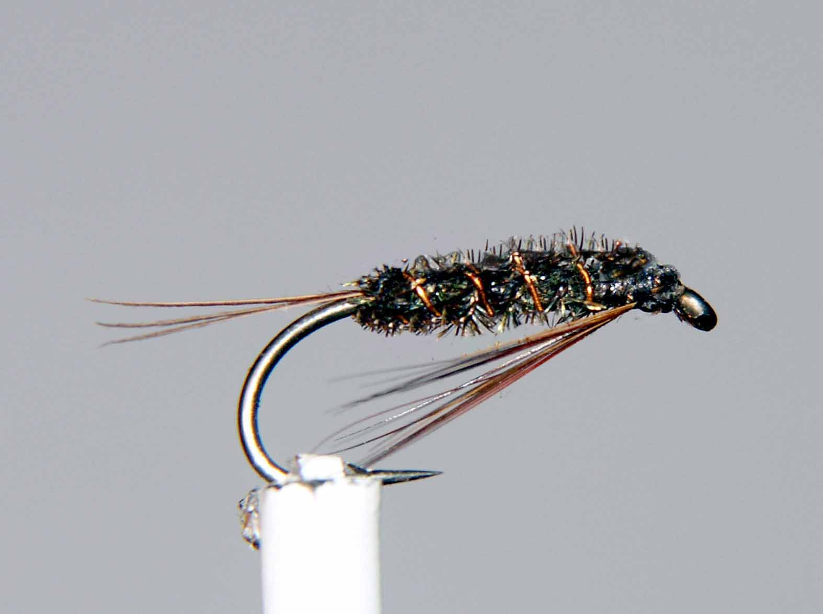

Materials

Size 10-16 medium/heavy wire hook, brown/black thread, peacock herl, light game/furnace cock hackles, copper rib.

Tying Sequence

- Run the thread down the shank to the start of the bend and tie in a few cock hackle fibres to form the tail.
- Tie in a suitable length of copper wire for the rib at the start of the bend (varying the thickness of wire will help the pattern to sink).
- Tie in two peacock herls by the trimmed tips also at this point.
- Form a loop with the tying thread equal in length to the peacock herl and tie in also at the start of the bend, then return the thread up the shank to 2mm back from the eye.
- With a dubbing twister or hackle pliers spin the thread and the herl to form a tight rope and wind this up the shank to the thread in touching turns. Tie off and trim the waste.
- Rib the body with the copper wire in open, even spirals in the opposite direction to the body material and tie off and trim the waste.
- Tie in either a false hackle or beard hackle, which is swept back, then tied under the shank.
- Finally, trim any waste, wind a small neat head, whip finish and finally varnish the head.

