BLACK SPIDER

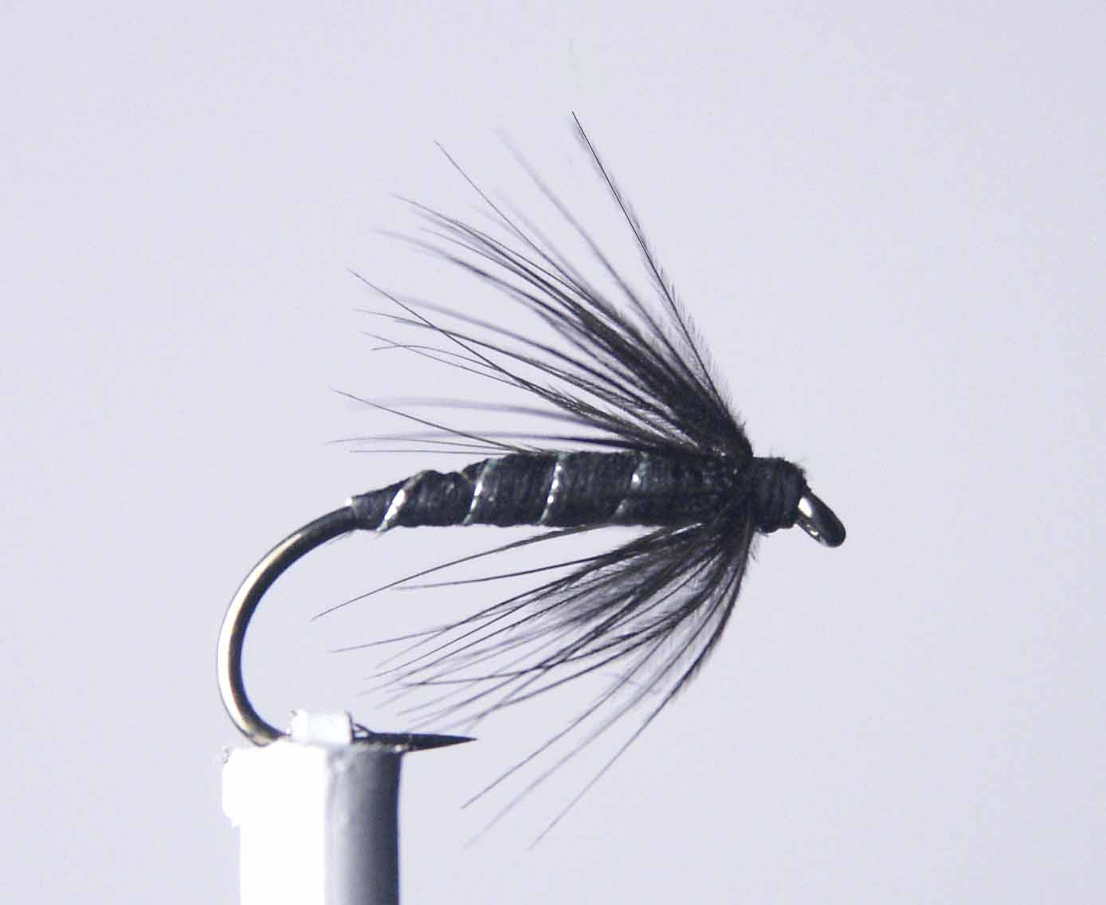

Materials

Size 8-14 medium to heavy weight hook, black thread, black floss, silver wire or silver oval tinsel, black hen hackle

Tying Sequence

- Attach thread to shank 2mm behind the hook eye then wind in close touching turns down the shank to a position just in front of the bend.
- Tie in a 100mm (4”) length of silver wire.
- Tie in a 200mm (8”) length of black floss and bind these materials down and return the thread to a position approx. 3mm back from the eye. Trim the waste ends.
- Wind the black floss in touching turns up towards the eye then back down to the bend and then finally back again to the thread position trying to create a tapered effect. Tie off and trim waste.
- Wind the silver wire in open spirals down the body and tie off 3mm back from the eye.
- Select a suitable black hen hackle approx. 11/2- 2 x the gape width of the hook and prepare hackle to tie in by the tip of the feather.
- Trim tip of hackle leaving approx 3mm to tie in with the concave side of the feather facing down and secure with 3 tight turns of thread.
- Carefully lift hackle by the stalk to an upright position and gently stroke back all of the fibres to lay either side of the stalk.
- Wind the Hackle in tight turns towards the eye stroking the fibres back as you go three or four turns will be ok.
- Tie off and trim the excess hackle stalk and wind a neat head slightly over the base of the hackle to lay the fibres at an angle of approximately 45 degrees.
- Whip finishing and varnishing the head

