**CHILTERN FLY TYING & FLY FISHING**

**LINDSAY’S SEDGEHOG**

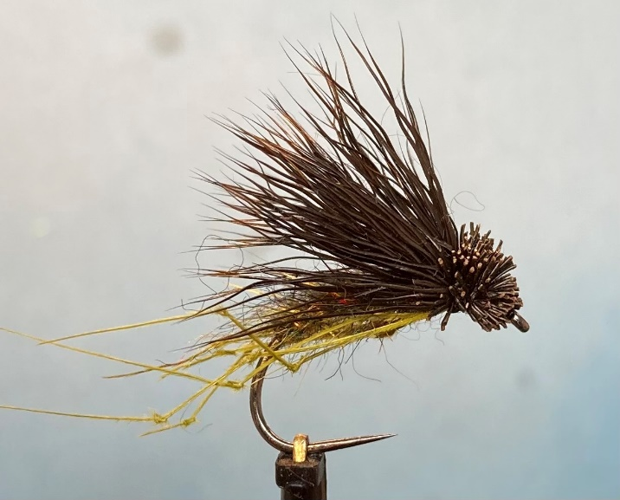

Materials:

Medium wire sedge hook size 10 (Hanak H300BL Czech Nymph); black thread ( Semperfli Nano 50D); light gold wire (Semperfli Light gold 0.2mm); olive dubbing (Andrews Scruffy Dubbing – sooty olive); olive green hopper legs; brown dyed deer hair wing.

Tying Instructions

1. Apply a smear of super glue and attach the thread and wind down a foundation round the bend.
2. Tie in the wire rib and wind forward to secure the waste then take the thread back around the bend.
3. Apply the dubbing to the thread and wind a body up the shank to approximately 3mm from the eye. Add enough dubbing to form a tapered body.
4. Wind the ribbing over the dubbed body in the opposite direction to the dubbing and tie off at the thread position.
5. Brush out the dubbing then turn the fly in the vice (or rotate the vice)
6. Select 2 slips of three hopper legs and tie each side of the shank so that they sit slightly below. Bind down the waste and trim.
7. Turn the fly back and wind the thread back to where the legs are tied in.
8. Cut a bunch of the deer hair approximately 1cm (3/8 inch) diameter away from the skin and combe out any underfur and loose hairs and place in a hair stacker.
9. Having aligned the tips in the stacker offer the bunch of hair up to the fly so that the tips are approximately the same length as the hook.
10. Holding the wing in place with the other hand make a pinch and loop with the thread and gently pull the thread down onto the shank. Keeping pressure on the deer hair take more pinch and loop wraps of the thread increasing the pressure on the thread with each turn as the hair starts to flair.
11. Let go of the deer hair wing and check that it is in the right place then take further wraps of thread through the waste hair as it flairs.
12. Once you are happy that the wing is secure pull all of the fibres forward and wind securing wraps of thread up against the wing.
13. Whilst still holding the fibres back whip finish the thread.
14. Trim the butts of the deer hair to form a ‘muddler’ style head. When you are happy with the shape hold the wing back and apply a lighter flame to the butts to tidy up any loose fibres.
15. Using something like a hackle guard over the fly to expose the head apply varnish to the head.