CHILTERN FLY TYING & FLY FISHING

LEE’S BLACK & PEACOCK SPIDER

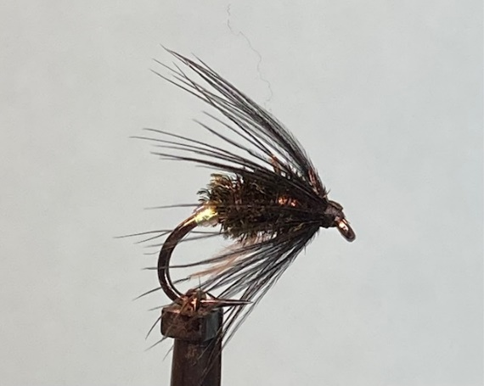

Materials:
Black heavy weight grub hook size 14 (Fulling Mill FM11 67); fine lead wire; fine pearl mylar size 14; natural peacock herl; black dyed hen pheasant hackle or black genetic hen hackle; black thread (UTC 70 den).

Tying Instructions:

- Place the hook in the vice and wind the thread onto the shank and continue to a point opposite the hook barb.
- Add a smear of superglue or varnish to the thread and wind on the fine lead wire in touching turns from approximately the start of the bend and finish about 2mm behind the eye.
- Remove any surplus wire then wind the thread over the wire in criss cross wraps to secure. Return the thread to the start of the bend.
- Catch in a length of the pearl mylar at this position and tie a butt of the pearl up against the lead wire.
- Tie off at this position and wind the thread to a position 1-2mm behind the hook eye.
- Select a suitable size of hackle (whose fibres are approximately1 1/2 times the hook gape and prepare it by stroking the fibres back from the tip to expose a gap in the hackle. Trim the very tip of the feather to leave approximately 3-4 mm.
- Tie this tip in on top of the shank with the stalk facing forward and the good side of the hackle facing down remembering to leave a little gap between the hackle fibres and the tying thread.
- Continue winding the thread down the shank trapping the waste hackle fibres in as you go to a position up against the pearl mylar butt.
- Select 2 peacock herl fibres and place tips together and trim, then tie in up against the butt.
- At this point you can decide whether to tie a loop of thread in to form a reinforcing thread for the peacock, or to add a thin smear of varnish or glue to wind the herl over so reinforcing the delicate nature of the peacock herl.
- Once you have wound the body down the shank towards the eye you can double the herl back over the body to form a lozenge shape finishing at a point 2mm back from the eye.
- Tie off at this point and trim the waste herl.
- Taking a pair of hackle pliers grip the stalk of the hackle and bend if towards the back of the hook to crease the hackle stalk making it easier to wind the stalk around the shank.
- Lift the hackle to the vertical and then with moistened fingers stroke the hackle fibres either side of the hackle stalk so that all the hackle fibres point to the rear before being wound in with successive forward turns of the hackle. 2 or 3 turns should be sufficient.
- Bend the remainder of the stalk back on itself and secure with turns of thread.
- Whip finish with turns of thread up against the hackle then remove the waste stalk and thread.
- Finally varnish the head.

