**CHILTERN FLY TYING & FLY FISHING**

**PARACHUTE ADAMS DRY FLY**

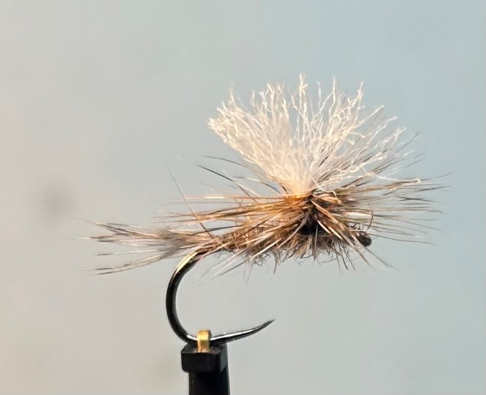

Materials:

Light wire hook size 12-18; fine black/white thread; Grizzle and Game cock hackle fibre tail; Adams grey body dubbing; Antron or similar wing post material; Grizzle and Game genetic cock hackle parachute.

Tying Instructions:

1. Place the hook in the vice, tie in the thread at the eye then wind a foundation to the start of the bend.
2. Pull off a few grizzle and game cock hackle fibres from the hackle stalk and bunch together to mix the fibres, then tie in to form a tail equal in length to the shank. Bind the waste down the shank and trim any excess then return the thread to the tail position.
3. Dub on the body material to form a slim ‘dubbing rope’ then wind a slightly tapered body up the shank to just over 2/3rds.
4. Take approximately 40mm of the wing post material and position on top of the shank at the end of the body at the mid-point of the material and secure with 2 or 3 wraps of thread. Lift the 2 strands wing post material vertically and secure with wraps of thread in front and behind.
5. Whilst holding the wing post taught wind the thread horizontally around and up the post approximately 2mm. then wind the thread back down and position the thread in front of the post.
6. Select suitable sized grizzle and game cock hackles. With the good side facing you, strip off a few more hackle fibres on the right side of the stalk than the left. Do this for both hackles.
7. Offer one hackle up to the wing post and secure in position with 2 or 3 wraps of thread so that the left side of the hackle is approximately level with the top of the post.
8. When you are happy with the position bind down the waste stalk.
9. Do the same for the other hackle and once you are happy with the position bind down the stalk towards the eye then trim if necessary. Return the thread to a position in front of the post.
10. Wind the thread horizontally around the post to secure the stalks and continue binding the hackle stalks up the post to the top of the thread, then wind back down. Take the thread up to the eye.
11. Dub on some more of the body material and wind the dubbing rope back towards the post finishing behind the post. Return the thread in front of the post.
12. Take the hook out of the vice and reposition with the shank vertical and the wing post horizontal.
13. If either hackle is a little on the short side you will need to use some hackle pliers. Take the last hackle tied in and wind the hackle around the wing post making sure each successive turn is below the previous turn. Do not tie too many turns in order to leave space for the other hackle
14. Take the thread and wind it around the base of the post underneath the hackle with 2 turns then wind another turn on top of the waste hackle making sure that you avoid trapping too many hackle fibres. This will secure the hackle tip. Remove the waste hackle stalk carefully cutting preferably with a scalpel to avoid cutting too many hackle fibres.
15. Now wind the other hackle through the first hackle until you get to the base of the post where you can tie it off in the same manner as the first.
16. Remove the waste hackle carefully then whip finish the thread around the post through the hackle fibres. A dab of thin varnish on the thread will secure it. Take care when lowering the final whip finish so that it doesn’t trap too many fibres.
17. Return the hook to the original position and pull the 2-wing strand apart to tighten the post then drop a small drop of thinned varnish onto the post to sink in and help with the durability of the wing.
18. Trim the wing post to length then apply some liquid floatant to the hackle and wing post.